1. [**Description of models**](https://flexagon.com/blog/7-software-development-models-you-should-know/)
2. **Explain Agile Process Model**.

Agile SDLC model is a combination of iterative and incremental process models with focus on process adaptability and customer satisfaction by rapid delivery of working software products.

Agile Methods break the product into small incremental builds. These builds are provided in iterations. Each iteration typically lasts from about one to three weeks. Every iteration involves cross functional teams working simultaneously on various areas like planning, requirements analysis, design, coding, unit testing, and acceptance testing.

At the end of the iteration a working product is displayed to the customer and important stakeholders.

The Agile model believes that every project needs to be handled differently and the existing methods need to be tailored to best suit the project requirements. In agile the tasks are divided into time boxes (small time frames) to deliver specific features for a release.

Iterative approach is taken and working software build is delivered after each iteration. Each build is incremental in terms of features; the final build holds all the features required by the customer.

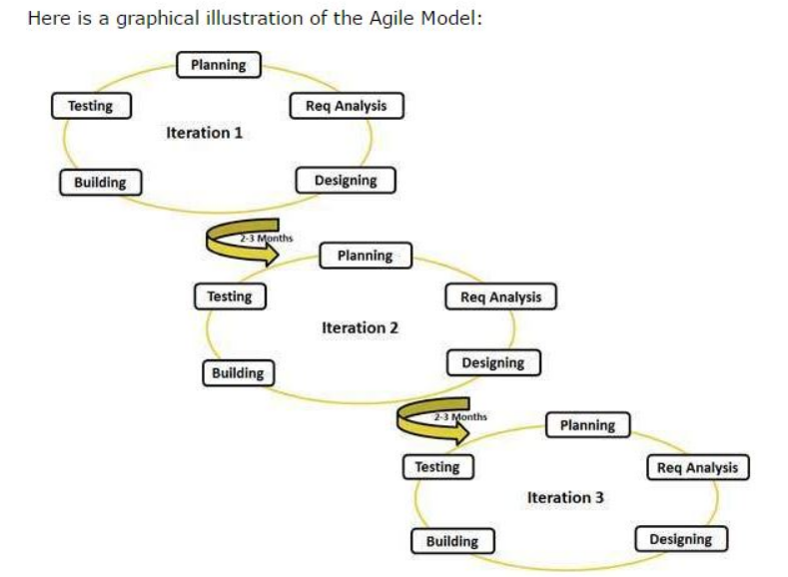

Agile thought process had started early in the software development and started becoming popular with time due to its flexibility and adaptability.

**Advantages** of Agile model:

Customer satisfaction by rapid, continuous delivery of useful software.

People and interactions are emphasized rather than process and tools. Customers, developers and testers constantly interact with each other.

Working software is delivered frequently (weeks rather than months).

Face-to-face conversation is the best form of communication.

Close, daily cooperation between business people and developers.

Continuous attention to technical excellence and good design.

Regular adaptation to changing circumstances.

Even late changes in requirements are welcomed

**Disadvantages**:

Less documentation

Maintenance problem

Lack of testing strategy

Not changing the objectives

**Agile Process Models:**

Extreme Programming (XP)

Adaptive Software Development (ASD)

Dynamic Systems Development Method (DSDM)

Scrum

Crystal

List item

Feature Driven Development (FDD)

Agile Modeling (AM)

**steps in agile process model**

The Agile process model is based on iterative and incremental development. **i**Here are the typical steps in the Agile process model:

**Project planning**: In this step, the team defines the scope of the project, identifies the stakeholders, and creates a product backlog, which is a prioritized list of features and requirements.

**Sprint planning:** The team selects a set of items from the product backlog to work on during the upcoming sprint. The team also defines the sprint goal and creates a sprint backlog, which is a detailed plan for the sprint.

**Sprint execution:** During this step, the team works on the items in the sprint backlog, using iterative development cycles to continuously build, test, and integrate the software.

**Daily stand-up meetings**: The team meets daily to discuss progress, identify any obstacles, and plan the work for the next 24 hours.

**Sprint review:** At the end of each sprint, the team demonstrates the working software to stakeholders, collects feedback, and adjusts the product backlog as needed.

**Sprint retrospective**: The team reflects on the previous sprint, identifies what went well and what could be improved, and defines action items for the next sprint.

**Repeat**: The team repeats these steps for each sprint until the project is complete.

Throughout the Agile process, communication and collaboration among team members and stakeholders is key. The team works closely with the customer to ensure that the software meets their needs, and adjusts the plan as needed based on feedback and changing priorities.

1. **Explain Kanban Model.**

Kanban is a software development methodology that emphasizes visual management, continuous delivery, and incremental improvement. The name "Kanban" comes from the Japanese word for "visual signal," which refers to the use of a visual board to track work in progress.

In the Kanban model, work is broken down into small, manageable pieces and each piece is represented by a card or sticky note on a Kanban board. The board is typically divided into columns representing the stages of the development process, such as "to do," "in progress," and "done." Each card is moved across the board as it progresses through the stages of the process, providing a visual representation of the work in progress.

The Kanban model has several **key principles:**

**Visual management**: The use of a visual board to track work in progress provides a clear and transparent view of the development process, helping to identify bottlenecks and improve efficiency.

**Limiting work in progress:** The number of cards allowed in each column is limited, preventing the team from taking on too much work at once and helping to maintain a steady flow of work.

**Continuous delivery:** Work is delivered in small, frequent increments, allowing the team to quickly respond to changing requirements and feedback from stakeholders.

**Continuous improvement:** The team regularly reviews and reflects on their process, identifying areas for improvement and making incremental changes to improve efficiency and quality.

The Kanban model is flexible and adaptable, making it well-suited for teams that work in a dynamic and changing environment. It is often used in Agile software development, but can be applied to other types of projects as well. The focus on visual management and continuous improvement helps teams to identify and address issues quickly, leading to a more efficient and effective development process.

**steps in kanban model**

The Kanban model is a software development methodology that emphasizes visual management, continuous delivery, and incremental improvement. Here are the typical steps in the Kanban model:

**Visualize the workflow:** The team maps out the development process and creates a visual board, such as a whiteboard or electronic tool, to represent the workflow. Each stage of the process is represented by a column on the board.

**Define work items:** Work items are broken down into small, manageable pieces and each piece is represented by a card or sticky note on the Kanban board.

**Limit work in progress:** The number of cards allowed in each column is limited, preventing the team from taking on too much work at once and helping to maintain a steady flow of work.

**Implement pull-based system:** Work is pulled into the next column only when there is available capacity, rather than being pushed from the previous column.

**Continuous delivery**: Work is delivered in small, frequent increments, allowing the team to quickly respond to changing requirements and feedback from stakeholders.

**Continuous improvement**: The team regularly reviews and reflects on their process, identifying areas for improvement and making incremental changes to improve efficiency and quality.

**Manage flow**: The team tracks the flow of work across the board, identifying and addressing bottlenecks and impediments to ensure a smooth and efficient process.

**Iterate**: The team repeats these steps, making incremental improvements to the process over time.

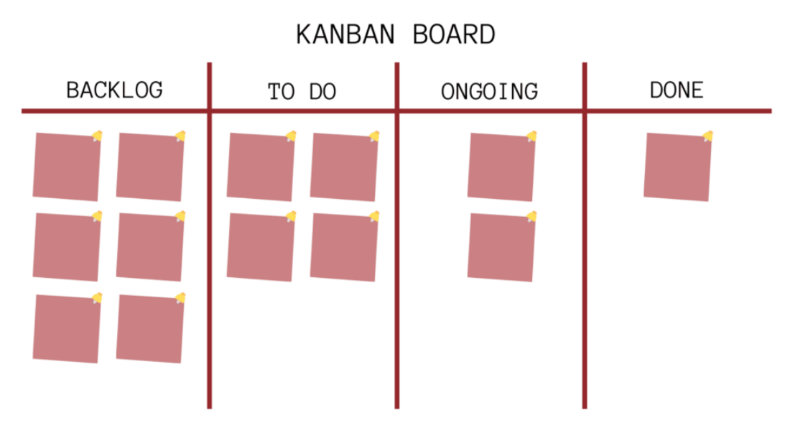

**Disadvantages**:

poor way to define and maintain timeframes

Planning long projects is very difficult.

Throughout the Kanban process, communication and collaboration among team members and stakeholders is key. The team works closely with the customer to ensure that the software meets their needs, and adjusts the plan as needed based on feedback and changing priorities. (The focus on visual management and continuous improvement helps teams to identify and address issues quickly, leading to a more efficient and effective development process.) - **advantage**

1. **Explain Evolutionary process model**

The evolutionary process model is an **iterative and incremental** software development methodology that involves delivering a basic working version of the software and then refining it through a series of iterations. The model is based on the idea of continuous improvement, with each iteration building on the previous one to produce a final product that meets the customer's needs. Here are the typical steps in the evolutionary process model:

**Requirements gathering**: The team works with the customer to gather requirements and define the initial scope of the project.

**Prototype development:** A basic working version of the software is developed, based on the initial requirements. The prototype is not a final product, but rather a starting point for the iterative development process.

**Evaluation**: The customer evaluates the prototype and provides feedback on its functionality, usability, and other aspects.

**Iterative development**: The team works on refining the software based on the customer's feedback, delivering a new version at the end of each iteration.

**Testing**: Testing is conducted throughout the development process to ensure that the software meets the customer's requirements and is free of errors.

**Delivery**: The final version of the software is delivered to the customer, meeting their requirements and expectations.

**Maintenance**: The software is maintained and updated as needed to ensure that it continues to meet the customer's needs and remains up-to-date.

(The evolutionary process model is **highly flexible and adaptable**, making it well-suited for projects with changing requirements or uncertain scope. It allows the team to **quickly respond to customer feedback** and make changes as needed, leading to a final product that meets the customer's needs and expectations. However, the model can be **more time-consuming and costly** than other software development methodologies, as it involves multiple iterations of development and testing.) - **adv and disadvantages**

1. **With a neat diagram explain the spiral model of software development.**

The spiral model is similar to the incremental model, with more emphasis placed on risk analysis. The spiral model has four phases: Planning, Risk Analysis, Engineering and Evaluation.

A software project repeatedly passes through these phases in iterations (called Spirals in this model).

The baseline spiral, starting in the planning phase, requirements are gathered and risk is assessed. Each subsequent spirals builds on the baseline spiral.

Planning Phase: Requirements are gathered during the planning phase. Requirements like ‘BRS’ that is ‘Bussiness Requirement Specifications’ and ‘SRS’ that is ‘System Requirement specifications’.

Risk Analysis: In the risk analysis phase, a process is undertaken to identify risk and alternate solutions. A prototype is produced at the end of the risk analysis phase. If any risk is found during the risk analysis then alternate solutions are suggested and implemented.

Engineering Phase: In this phase software is developed, along with testing at the end of the phase. Hence in this phase the development and testing is done.

Evaluation phase: This phase allows the customer to evaluate the output of the project to date before the project continues to the next spiral.

Diagram of Spiral model:

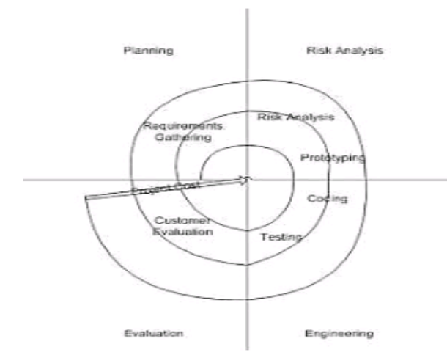

Advantages of Spiral model:

High amount of risk analysis hence, avoidance of Risk is enhanced.

Good for large and mission-critical projects.

Strong approval and documentation control.

Additional Functionality can be added at a later date.

Software is produced early in the software life cycle.

Disadvantages of Spiral model:

Can be a costly model to use.

Risk analysis requires highly specific expertise.

Project’s success is highly dependent on the risk analysis phase.

Doesn’t work well for smaller projects.

When to use Spiral model:

When costs and risk evaluation is important

For medium to high-risk projects

Long-term project commitment unwise because of potential changes to economic priorities

Users are unsure of their needs

Requirements are complex

New product line

Significant changes are expected (research and exploration)

1. **Write short note on: SCRUM**

Scrum is an Agile software development framework that emphasizes collaboration, iterative development, and continuous improvement. It is a popular methodology for managing complex projects and is particularly well-suited to projects with rapidly changing requirements. Here are the typical steps in the Scrum process:

**Product Backlog Creation**: The product owner creates a product backlog, which is a prioritized list of features, bug fixes, and other development tasks.

**Sprint Planning**: The Scrum team plans the upcoming sprint, which is a short iteration of development work typically lasting two to four weeks. The team selects items from the product backlog and defines the sprint goals and deliverables.

**Sprint Execution**: The Scrum team develops the selected items during the sprint, with daily meetings to monitor progress and address any issues.

**Sprint Review**: At the end of the sprint, the team demonstrates the completed work to the product owner and stakeholders, and feedback is gathered to inform the next sprint.

**Sprint Retrospective**: The Scrum team reflects on the sprint, identifying what went well, what didn't go well, and areas for improvement. The team then creates a plan to implement changes and improvements in the next sprint.

**Advantages** of Scrum:

**Flexibility**: Scrum is highly flexible, with a focus on adaptability and responsiveness to changing requirements and priorities.

**Collaboration**: Scrum emphasizes collaboration and teamwork, with a focus on continuous improvement and learning.

**Transparency**: Scrum provides transparency into the development process, with frequent updates and opportunities for feedback and review.

**Faster Time to Market**: Scrum allows teams to deliver working software quickly and frequently, which can accelerate time to market and provide early value to stakeholders.

**Disadvantages** of Scrum:

**Complexity**: Scrum can be complex to implement, requiring a high degree of organization, planning, and communication.

**Resource Requirements**: Scrum requires significant resources, including time, personnel, and infrastructure, which can be a barrier to adoption for some teams.

**Uncertainty**: Scrum's focus on flexibility and adaptability can also create uncertainty, as requirements and priorities can change rapidly.

**Overemphasis on Process**: Scrum can sometimes lead to an overemphasis on process and methodology, rather than on actual software development and delivery.

Overall, Scrum can be an effective software development methodology for complex projects with rapidly changing requirements. However, its implementation requires careful planning and management, and teams must be prepared to invest significant time and resources in the development process.

Scrum is a subset of Agile. It is a lightweight process framework for agile development, and the most widely-used one.

A “process framework” is a particular set of practices that must be followed in order for a process to be consistent with the framework. (For example, the Scrum process framework requires the use of development cycles called Sprints, the XP framework requires pair programming, and so forth.)

“Lightweight” means that the overhead of the process is kept as small as possible, to maximize the amount of productive time available for getting useful work done.

A Scrum process is distinguished from other agile processes by specific concepts and practices, divided into the three categories of Roles, Artifacts, and Time Boxes. These and other terms used in Scrum are defined below.

Scrum is most often used to manage complex software and product development, using iterative and incremental practices. Scrum significantly increases productivity and reduces time to benefits relative to classic “waterfall” processes. Scrum processes enable organizations to adjust smoothly to rapidly-changing requirements, and produce a product that meets evolving business goals.

An agile Scrum process benefits the organization by helping it to

Increase the quality of the deliverables

Cope better with change (and expect the changes)

Provide better estimates while spending less time creating them

Be more in control of the project schedule and state

Scrum has three roles: Product Owner, Scrum Master, and Team.

Product Owner: The Product Owner should be a person with vision, authority, and availability. The Product Owner is responsible for continuously communicating the vision and priorities to the development team. It’s sometimes hard for Product Owners to strike the right balance of involvement. Because Scrum values self-organization among teams, a Product Owner must fight the urge to micro-manage. At the same time, Product Owners must be available to answer questions from the team.

Scrum Master: The Scrum Master acts as a facilitator for the Product Owner and the team. The Scrum Master does not manage the team. The Scrum Master works to remove any impediments that are obstructing the team from achieving its sprint goals. This helps the team remain creative and productive while making sure its successes are visible to the Product Owner. The Scrum Master also works to advise the Product Owner about how to maximize ROI for the team.

Team: According to Scrum’s founder, “the team is utterly self- managing.” The development team is responsible for self- organizing to complete work. A Scrum development team contains about seven fully dedicated members (officially 3-9), ideally in one team room protected from outside distractions. For software projects, a typical team includes a mix of software engineers, architects, programmers, analysts, QA experts, testers, and UI designers. Each sprint, the team is responsible for determining how it will accomplish the work to be completed. The team has autonomy and responsibility to meet the goals of the sprint.

1. **Explain umbrella activities of software engineering**

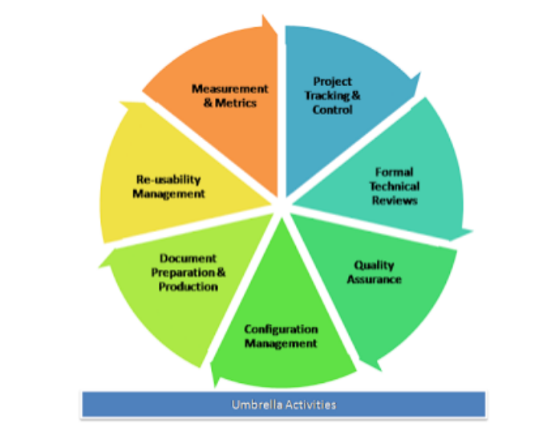

Software project tracking and control: When plan, tasks, models all have been done then a network of software engineering tasks that will enable to get the job done on time will have to be created.

Formal technical reviews: This includes reviewing the techniques that has been used in the project.

Software quality assurance: This is very important to ensure the quality measurement of each part to ensure them.

Software configuration management: Software configuration management (SCM) is a set of activities designed to control change by identifying the work products that are likely to change, establishing relationships among them, defining mechanisms for managing different versions of these work products.

Document preparation and production: All the project planning and other activities should be hardly copied and the production get started here.

Re-usability management: This includes the backing up of each part of the software project they can be corrected or any kind of support can be given to them later to update or upgrade the software at user/time demand.

Measurement & Metrics: This will include all the measurement of every aspects of the software project.

Risk management: Risk management is a series of steps that help a software team to understand and manage uncertainty. It’s a really good idea to identify it, assess its probability of occurrence, estimate its impact, and establish a contingency plan that─ ‘should the problem actually occur’.

.

1. **Differentiate between waterfall and spiral model.**

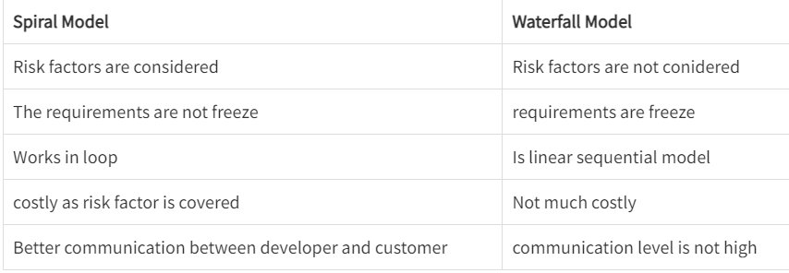

1. **Explain 3 P’s of software engineering.**

The 3 P's of software engineering are People, Process, and Product. These are the essential components that affect the success of any software project. Here's an explanation of each P:

People:

The people involved in a software project include developers, testers, project managers, and other stakeholders. People are the most critical factor in software development, as they contribute to the project's success through their skills, experience, and collaboration. People's skills and teamwork can significantly impact the project's outcome.

Process:

The process is the methodology used to develop the software, and it defines the stages of development, roles and responsibilities, and the tools and techniques used. An efficient and effective process helps ensure quality, predictability, and on-time delivery of the software product. Process improvement is a continuous effort to improve efficiency and effectiveness.

Product:

The software product is the end result of the development process. The product should meet the user's requirements and expectations, be of high quality, be delivered on time, and be cost-effective. The product is the output of the development process, and its success depends on the quality of the process and people involved.

The 3 P's of software engineering help in understanding the factors that influence the success of software projects. A well-defined and well-executed process, a skilled team of developers and stakeholders, and a high-quality software product are the key factors that contribute to the success of software projects.

1. **Compare the main features and practices at each of the key phases of the agile approach and more traditional approaches of the software development life cycle.**

Agile and traditional approaches to software development have different key phases and practices. Here is a comparison of the main features and practices at each phase:

Requirements gathering and analysis:

In traditional approaches, the requirements gathering and analysis phase is typically long and involves a detailed specification document. In contrast, in agile approaches, the focus is on continuous collaboration between the development team and the customer, with requirements evolving over time.

Design:

In traditional approaches, the design phase follows the requirements phase and typically involves creating detailed design documents. In agile approaches, design is an ongoing process that happens alongside development, with the emphasis on delivering working software quickly.

Development:

In traditional approaches, development is a separate phase that follows design, with a focus on producing a fully functional product before testing. In agile approaches, development is iterative and collaborative, with frequent releases and continuous integration.

Testing:

In traditional approaches, testing is a separate phase that follows development, with a focus on finding and fixing bugs. In agile approaches, testing is integrated into the development process, with frequent automated testing and continuous feedback from the customer.

Deployment:

In traditional approaches, deployment is a separate phase that follows testing, with a focus on ensuring the software is ready for release. In agile approaches, deployment is integrated into the development process, with frequent releases and continuous deployment.

Maintenance:

In traditional approaches, maintenance is a separate phase that follows deployment, with a focus on bug fixing and support. In agile approaches, maintenance is ongoing, with continuous improvement and new features added in each release.

Overall, the main differences between traditional and agile approaches to software development are the focus on collaboration, flexibility, and continuous improvement in agile approaches. Agile approaches emphasize delivering working software quickly, with frequent feedback from the customer and a focus on adapting to changing requirements. Traditional approaches, on the other hand, emphasize detailed planning, documentation, and a structured approach to development.

1. **What is Cost Estimation? Explain LOC Method.**

Cost estimation is the process of predicting the cost of a software project. It is an essential aspect of software project management, as accurate cost estimation helps in effective budgeting and resource allocation. One of the methods used for cost estimation in software development is the Lines of Code (LOC) method.

The LOC method is a technique that estimates the cost of a software project based on the number of lines of code (LOC) that will be written. The method involves the following steps:

Determine the size of the project: The first step is to estimate the size of the software project in terms of the number of lines of code that will be written. This can be done by reviewing the project requirements and specifications.

Determine the cost per line of code: Once the size of the project has been estimated, the next step is to determine the cost per line of code. This can be done by analyzing historical data or industry benchmarks for similar projects.

Multiply the size of the project by the cost per line of code: The final step is to multiply the estimated size of the project by the cost per line of code to get the estimated cost of the project.

The LOC method has several advantages, including:

Simplicity: The LOC method is simple and easy to understand, making it a popular choice for cost estimation.

Accuracy: The LOC method can be accurate if the project size and cost per line of code are estimated correctly.

However, the LOC method also has some disadvantages, including:

Dependency on lines of code: The LOC method relies on the number of lines of code to estimate the project cost, which may not always be a good measure of complexity or effort.

Lack of consideration for other factors: The LOC method does not consider other factors that can impact project cost, such as team experience, technology, and project scope.

In summary, the LOC method is a straightforward technique for cost estimation in software development that relies on the number of lines of code. While it has its advantages, it is important to consider other factors and use multiple estimation techniques for more accurate cost predictions.

1. Develop a SRS for Hospital.
2. Draw the Data Flow diagram(upto 2 level) for the safe home software
3. **Explain requirement elicitation in detail. Explain any two methods**

Requirement elicitation is the process of discovering, analyzing, and documenting the needs and expectations of stakeholders for a software system. This is a crucial step in software development as it lays the foundation for the entire project. The goal of requirement elicitation is to identify the necessary features, functions, and constraints of the system in order to meet the stakeholders' needs and expectations.

There are several methods used for requirement elicitation, including:

Interviews: One of the most common methods for requirement elicitation is conducting interviews with stakeholders. Interviews can be conducted individually or in groups, and can be structured or unstructured. The purpose of the interview is to ask stakeholders open-ended questions to gather their perspectives on the system and its requirements.

Workshops: Workshops are another popular method for requirement elicitation. They involve bringing together stakeholders and development team members to discuss the system and its requirements. Workshops can be used to brainstorm ideas, identify user stories, and prioritize requirements.

Two other methods for requirement elicitation are:

Surveys: Surveys can be used to gather information from a large number of stakeholders in a cost-effective way. Surveys can be conducted online or in-person, and can be used to gather quantitative data on stakeholder needs and expectations.

Observations: Observations involve observing stakeholders in their natural environment to understand their needs and expectations for the system. This method can be useful for understanding how stakeholders currently perform tasks and identifying opportunities for improvement.

In general, effective requirement elicitation requires clear communication, active listening, and a thorough understanding of the stakeholders and their needs. It is important to use a combination of methods to ensure that all stakeholders are heard and that their needs are addressed. Additionally, requirement elicitation should be an iterative process, with regular feedback and refinement of requirements throughout the software development lifecycle.

1. **Explain feasibility studies in detail.**

As the name implies, feasibility study is an analysis of the viability of an idea. It ensures that a project is legally and technically feasible and economically justifiable.

Moreover this study can be used in various ways with focus on the proposed business. It tells us whether a project is worth doable or not? Feasibility study is a must because:

Every Project is not doable.

Not every project should be done.

Not every project makes use of effective resources of company.

In its simplest terms, the two criteria to judge feasibility are cost required and value to be attained. A well-designed study should provide a historical background of the business or project, a description of the product or service, accounting statements, details of the operations and management, marketing research and policies, financial data, legal requirements and tax obligations. Generally, such studies precede technical development and project implementation.

Feasibility study is used for...

To determine whether the objectives stated in the assignment brief are reasonably attainable within the limitation and financial constraints period.

To define major problem areas, so that the system analyst can plan the strategy for the field investigation.

To find areas where potential exists for making saving in money, time or effort.

To determine the approximate time required for the full investigation and cost.

To discover the areas where some specialist knowledge needed for the full investigation.

Five different areas of Project Feasibility:

Technical Feasibility assessment is focused on the present technical resource available in the organization. It studies if the technical resources including the technical team are capable of converting the ideas into working system. It also evaluates the hardware and the software requirement of the proposed system.

Economic Feasibility studies enable organizations to assess the viability, cost and benefits of projects before financial resources are allocated. They also provide independent project assessment and enhance project credibility. It also helps to determine the positive economic benefits to the organization that the proposed system will provide. It includes quantification and identification of all the benefits expected. This assessment typically involves a cost/ benefits analysis of the project.

Legally Feasibility of the project determines whether the proposed system conflicts with legal requirements like any data protection act or any social media law.

Operational Feasibility, under which we conduct a study to analyze and determine whether your business need can be fulfilled by using a proposed solution. It also measures how well a proposed system solves the problems, and takes advantage of the opportunities identified during scope definition and how it satisfies the requirements identified in the requirements analysis phase of system development.

Scheduling Feasibility is the most important in terms of project success. A project will fail if not completed on time. In scheduling feasibility we estimate how much time the system will take to complete and with our technical skill we need to estimate the period to complete the project using some methods.

Benefits

Conducting a feasibility study is always beneficial to the project and it gives a clear picture of your idea. Below are the top benefits of this study:

Gives focus to the project and alternative outline.

Narrows the business alternative.

Identifies the reason to do the project.

Enhances the success rate by considering multiple factor.

Helps in decision making of the project.

Provides a detailed documented status to the business.

1. **Short note on Process Metrics and project metrics.**

a) Process Metrics

These are the metrics pertaining to the Process Quality. They measure efficiency and effectiveness of various processes.

b) Project Metrics

These are the metrics pertaining to the Project Quality. They measure defects, cost, schedule, productivity and estimation of various project resources and deliverables.

Project Metrics -

Schedule Variance : Any difference between the scheduled completion of an activity and the actual completion is known as Schedule Variance. Schedule variance = ((Actual calendar days – Planned calendar days) + Start variance)/ Planned calendar days x 100.

Effort Variance: Difference between the planned outlined effort and the effort required to actually undertake the task is called Effort variance. Effort variance = (Actual Effort – Planned Effort)/ Planned Effort x 100.

Size Variance: Difference between the estimated size of the project and the actual size of the project (normally in KLOC or FP) Size variance = (Actual size – Estimated size)/ Estimated size x 100.

Requirement Stability Index: Provides visibility and understanding into the magnitude and impact of requirements changes. RSI = 1- ((No of changed + No of deleted + No of added) / Total no of Initial requirements) x100

Productivity (Project): It is a measure of output from a related process for a unit of input. Project Productivity = Actual Project Size / Actual Effort spent for the project

Productivity (for test case preparation) Productivity in test case preparation = Actual no of test cases/ actual effort spent on test case preparation

Productivity (for test case execution) Productivity in test case execution = actual number of test cases / actual effort spend on testing.

Productivity (defect detection) Productivity in defect detection = Actual number of defects (review + testing) / actual effort spent on (review + testing)

Productivity (defect fixation) Productivity in defect fixation = actual no of defects fixed/ actual effort spent on defect fixation

Schedule variance for a phase: The deviation between planned and actual schedule for the phases within a project. Schedule variance for a phase = (Actual Calendar days for a phase – Planned calendar days for a phase + Start variance for a phase)/ (Planned calendar days for a phase) x 100

Effort variance for a phase: The deviation between planned and actual effort for various phases within the project. Effort variance for a phase = (Actual effort for a phase – planned effort for a phase)/ (planned effort for a phase) x 100

Process Metrics:

Cost of Quality: It is a measure in terms of money for the quality performance within an organization Cost of quality = (review + testing + verification review + verification testing + QA + configuration management + measurement + training + rework review + rework testing)/ total effort x 100

Cost of poor Quality: It is the cost of implementing imperfect processes and products. Cost of poor quality = rework effort/ total effort x 100

Defect Density: It is the number of defects detected in the software during the development divided by the size of the software (typically in KLOC or FP) Defect density for a project = Total number of defects/ project size in KLOC or FP

Review Efficiency: defined as the efficiency in harnessing/ detecting review defects in the verification stage. Review efficiency = (number of defects caught in review)/ total number of defects caught) x 100

Testing Efficiency: Testing efficiency = 1 – ((defects found in acceptance)/ total no of testing defects) x 100

Defect removal efficiency: Gives the efficiency with which defects were detected and minimum defects were filtered down to the customer. Defect removal efficiency = (1 – (total defects caught by customer/ total no of defects)) x 100

1. Explain Mc Calls Quality Factor? ****
2. **What are the potential problems of prototyping models?**

While prototyping can be a valuable approach to software development, there are also some potential problems that can arise. Here are some of the most common problems associated with prototyping models:

Incomplete or inadequate requirements: Prototyping can be a risky approach if the requirements of the system are not fully understood. The prototypes produced may not fully meet the needs of the stakeholders or may not provide a complete solution to the problem.

Overemphasis on design and features: In some cases, prototyping can lead to an overemphasis on design and features, at the expense of other important aspects of software development, such as performance, security, and maintainability.

Limited scalability: Prototyping is often focused on a specific use case or a limited set of requirements, which can make it difficult to scale the system to meet broader needs or to accommodate changes in requirements.

Inadequate documentation: Prototyping models may not produce adequate documentation or may lack the necessary detail to fully understand the system.

Increased development costs: While prototyping can lead to faster development times in some cases, it can also lead to increased development costs if the prototypes need to be continually refined and revised.

Poor software quality: Prototyping may result in software that is less reliable, less secure, or more difficult to maintain over time.

Limited stakeholder involvement: If the stakeholders are not fully involved in the prototyping process, the prototypes produced may not fully meet their needs or expectations.

Overall, while prototyping can be a useful approach in some situations, it is important to carefully consider the potential problems and to use prototyping models judiciously to ensure that the software developed meets the needs of the stakeholders and is of high quality.

1. Write a note on: Service Oriented Software Engineering, Security Engineering. ***
2. El**aborate COCOMO method of cost estimation.**

COCOMO, or the Constructive Cost Model, is a widely used method for estimating the cost of software development projects. COCOMO was first introduced by Barry Boehm in 1981 and has since been revised and updated several times.

COCOMO is a parametric cost estimation model that uses historical data from previous projects to estimate the cost of a new project. The model is based on the assumption that there are three types of software projects: organic, semi-detached, and embedded. These project types differ in terms of size, complexity, and other characteristics, and each type requires a different approach to cost estimation.

The COCOMO model consists of three different sub-models, each of which is used to estimate the cost of a project at different stages of the software development lifecycle:

Basic COCOMO: This sub-model is used to estimate the effort required to develop a software project in terms of lines of code (LOC). The model uses a set of cost drivers that are used to adjust the estimated effort based on various project factors, such as complexity, reliability, and team experience.

Intermediate COCOMO: This sub-model is used to estimate the cost of a project in terms of person-months. The model uses a set of cost drivers similar to those used in Basic COCOMO, but also takes into account factors such as team cohesion and development process maturity.

Detailed COCOMO: This sub-model is used to estimate the cost of a project in more detail, taking into account factors such as staffing levels, task scheduling, and the use of various software tools and techniques.

The COCOMO model can be used in a variety of ways, depending on the level of detail and accuracy required. In general, the model is used to estimate the overall cost of a software development project, including the cost of development, testing, documentation, and other related activities.

One of the key advantages of the COCOMO model is that it is based on empirical data, which means that it is grounded in real-world experience and can be used to provide accurate estimates for a wide range of software projects. However, the model also has some limitations, including the fact that it is based on historical data and may not be applicable to all types of projects or development methodologies. Additionally, the model relies heavily on assumptions and estimates, which can lead to inaccurate or unreliable results if these assumptions are incorrect.

1. **List out requirement models. Explain any one of them.**

There are several requirement models that are commonly used in software engineering. Some of the most popular models include:

Use Case Model

User Stories

Entity Relationship Model

Data Flow Diagrams

State Transition Diagrams

Decision Tables

Activity Diagrams

Feature Model

Requirements Matrix

User Interface Mockups

One of the most widely used requirement models is the Use Case Model. This model is used to capture and document the functional requirements of a software system in the form of use cases. A use case is a description of a specific task or activity that a user of the system needs to perform. The use case model provides a visual representation of the system's functionality and how it is used by different actors or users.

The use case model is typically divided into several components, including actors, use cases, and relationships. Actors represent the different types of users or systems that interact with the software system, while use cases represent the different tasks or activities that these actors perform. Relationships between actors and use cases are used to describe how different actors interact with the system and which use cases are relevant for each actor.

The use case model is often used in conjunction with other requirement models, such as user stories and data flow diagrams. One of the key advantages of the use case model is that it provides a clear and concise way to document the functional requirements of a software system in a way that is easily understood by both technical and non-technical stakeholders.

However, there are also some potential limitations to the use case model. For example, the model may not be suitable for capturing non-functional requirements or requirements that are related to the overall architecture of the system. Additionally, the use case model may not be suitable for very complex systems or systems with a large number of actors and use cases, as it can become difficult to manage and maintain.

1. **Differentiate between FP based and LOC based cost estimation techniques.**

Both FP and LOC are units of measurement for software size. The size of a software that is subject to development is required in order to come up with accurate estimates of effort, cost and duration of a software project. Most parametric estimation models such as COCOMO accept size expressed in either FP or LOC as input.

Personally i prefer functional size of software expressed as FP for one very important reason: Size expressed using the FP metric stay constant regardless of which programming language or languages are used.

Since the industry has more than 700 programming languages and almost every application uses multiple languages, the consistency of FP metric allow economic studies that are not possible using LOC metric.

Function points can be seen as a universal IT-currency converter, giving a synthetic measure of the size of a software. For instance, it takes about 106.7 Cobol statements to construct 1 function point of software. It takes 128 C statements for the same 1 function point.

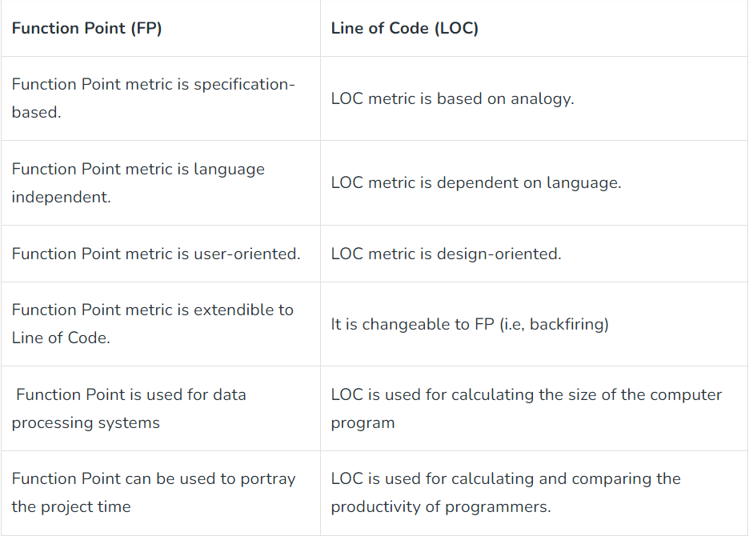

1. **What is the use of a use case diagram? Draw use case diagram diagram for hospital management system.**
2. **Discuss functional and non-functional requirements**

Requirements:

A requirement is a written description of a characteristic or capability that a new or upgraded product design must incorporate. They are often quite detailed, and describe what must be provided, not how it is to be provided. In other words, they exclude implementation details. Requirements, and the documents they appear in, are legally binding so the language used for them is very specific. In particular, a requirement that must be provided includes the words shall, or will.

Functional Requirements:

In Software engineering and systems engineering, a functional requirement defines a function of a system or its component. A function is described as a set of inputs, the behavior,and outputs.

Functional requirements may be calculations,technical details,data manipulation and processing and other specific functionality that define what a system is supposed to accomplish.Behavioral requirements describing all the cases where the system uses the functional requirements are captured in use cases.

Generally, functional requirements are expressed in the form "system must do <requirement>", while non-functional requirements are "system shall be <requirement>".

The plan for implementing functional requirements is detailed in the system design. The plan for implementing non-functional requirements is detailed in the system architecture.

A typical functional requirement will contain a unique name and number, a brief summary, and a rationale. This information is used to help the reader understand why the requirement is needed, and to track the requirement through the development of the system.

The crux of the requirement is the description of the required behavior, which must be clear and readable. The described behavior may come from organizational or business rules, or it may be discovered through elicitation sessions with users, stakeholders, and other experts within the organization.

Non-Functional Requirements:

In systems engineering and requirements engineering, a non-functional requirement is a requirement that specifies criteria that can be used to judge the operation of a system, rather than specific behaviors. They are contrasted with functional requirements that define specific behavior or functions.

Non-functional requirements are often called "quality attributes" of a system. Other terms for non-functional requirements are "qualities","quality goals","quality of service requirements","constraints" and "non-behavioral requirements".

Qualities that is non-functional requirements can be divided into two main categories:

Execution qualities, such as security and usability, which are observable at run time.

Evolution qualities, such as testability, maintainability, extensibility and scalability, which are embodied in the static structure of the software system.

Examples

A system may be required to present the user with a display of the number of records in a database. This is a functional requirement. How up-to-date [update] this number needs to be, is a non-functional requirement. If the number needs to be updated in real time, the system architects must ensure that the system is capable of updating the [displayed] record count within an acceptably short interval of the number of records changing.

Sufficient network bandwidth may be a non-functional requirement of a system.

1. **What is functional point analysis, explain in detail? What are its benefits in the engineering process?**

Functional Point Analysis (FPA) is a software estimation technique used to measure the size and complexity of a software system. It is based on the principle that the size of a software system is directly proportional to the amount of functionality it provides to its users. FPA is used to estimate the effort required to develop, test, and maintain the software system.

FPA involves identifying and classifying the different functions that a software system provides to its users. These functions are classified into different categories based on their complexity and the effort required to implement them. The five main categories of functions are:

External Inputs (EI): These are the functions that allow the user to input data into the system. For example, entering customer details into a CRM system.

External Outputs (EO): These are the functions that allow the system to output data to the user. For example, generating a report or displaying data on a dashboard.

External Inquiries (EQ): These are the functions that allow the user to query the system for information. For example, searching for a particular product in an e-commerce website.

Internal Logical Files (ILF): These are the functions that store and manipulate data within the system. For example, storing customer information in a database.

External Interface Files (EIF): These are the functions that allow the system to exchange data with other systems. For example, importing data from an external source into the system.

Once the functions have been identified and classified, each function is assigned a complexity rating based on the number of data elements involved and the processing required. The complexity rating is used to calculate the function point count, which is used as a measure of the size and complexity of the software system.

The benefits of FPA in the software engineering process are numerous. Firstly, FPA provides a more accurate estimate of the size and complexity of a software system, which can help in planning and resource allocation. It also allows for more accurate cost estimation and can help in negotiating contracts with clients.

Additionally, FPA can help in identifying areas of the software system that are more complex and may require more attention during the development process. This can help in identifying potential risks and mitigating them before they become major issues.

Finally, FPA can be used to track progress during the development process and to monitor the overall quality of the software system. This can help in ensuring that the software system meets the requirements of the client and is delivered on time and within budge

1. **What are the objectives of requirement analysis?**
2. **Draw the Data Flow diagram up to level 2 for a restaurant management system which has online food ordering, food delivering, GST calculation, invoice creation, and payments subsystems.**
3. **Draw a complete use case for anyone of the following activities.**

**Buying a stock using an online brokerage account.**

**Using your charge card for a meal at a restaurant.**

1. Draw the state chart diagram and activity diagram for ATM system.
2. 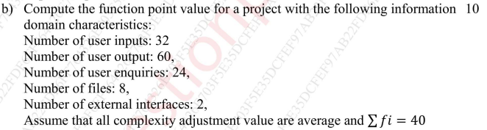
3. **List the principles of Software Design**

The design process should not suffer from ‘tunnel vision.’

The design should be traceable to the analysis model.

The design should not reinvent the wheel.

The design should “minimize the intellectual distance” between

the software and the problem as it exists in the real world.

The design should exhibit uniformity and integration.

The design should be structured to accommodate change.

The design should be structured to degrade gently, even when

aberrant data, events, or operating conditions are encountered.

Design is not coding, coding is not design.

The design should be assessed for quality as it is being created,

not after the fact.

The design should be reviewed to minimize conceptual

(semantic) errors.

.

1. **Explain Coupling and Cohesion.**

The “single-mindedness” of a module cohesion implies that a single component

or class encapsulates only attributes and operations that are closely related to one another and to the class or component itself.

Examples of cohesion

Functional: Typically applies to operations. Occurs when a

module performs one and only one computation

and then returns a result.

Layer: Applies to packages, components, and classes. Occurs when a higher layer

can access a lower layer, but lower layers do not access higher layers.

Communicational:

All operations that access the same data are

defined within one class.

In general, such classes focus solely on the

data in question, accessing and storing it.

Example: A StudentRecord class that adds,

removes, updates, and accesses various

fields of a student record for client

components.

**Coupling**

A qualitative measure of the degree to which classes or

components are connected to each other.

**Avoid:**

Content coupling:

Occurs when one

component

“surreptitiously modifies

data that is internal to

another component”

Violates information

hiding

**Use caution:**

Common coupling:

Occurs when a number of components all make

use of a global variable.

**Be aware:**

Routine call coupling:

Certain types of coupling occur routinely in

object-oriented programming.

Type use coupling

Inclusion or import coupling

1. **Explain different architectural styles.**

Architectural style describes a system category that

encompasses:

a set of components (e.g., a database, computational modules) that

perform a function required by a system,

a set of connectors that enable “communication, coordination, and

cooperation” among components, constraints that define how components can be integrated to form the system, and semantic models that enable a designer to understand the overall properties of a system.

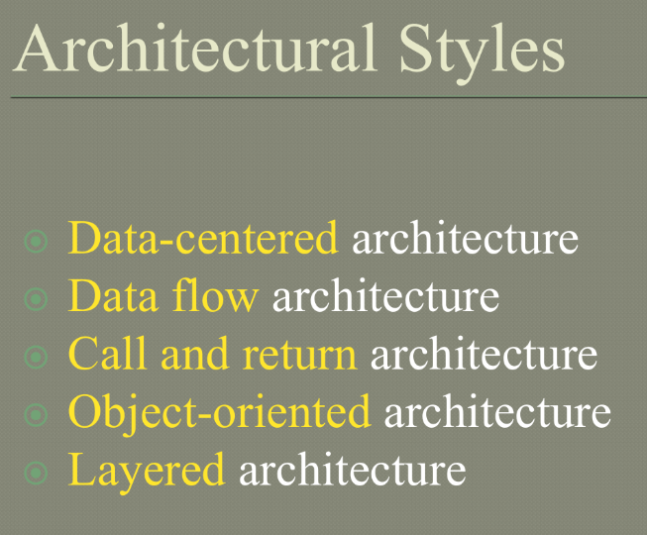

Data-centered architecture is a software architecture pattern that focuses on the storage, management, and access of data. In this architecture, data is considered the central component around which all other components are built.

In a data-centered architecture, data is stored in a central repository, such as a database, and all other components interact with the data through well-defined interfaces. The architecture is designed to ensure that data is accurate, consistent, and available to all components that need it.

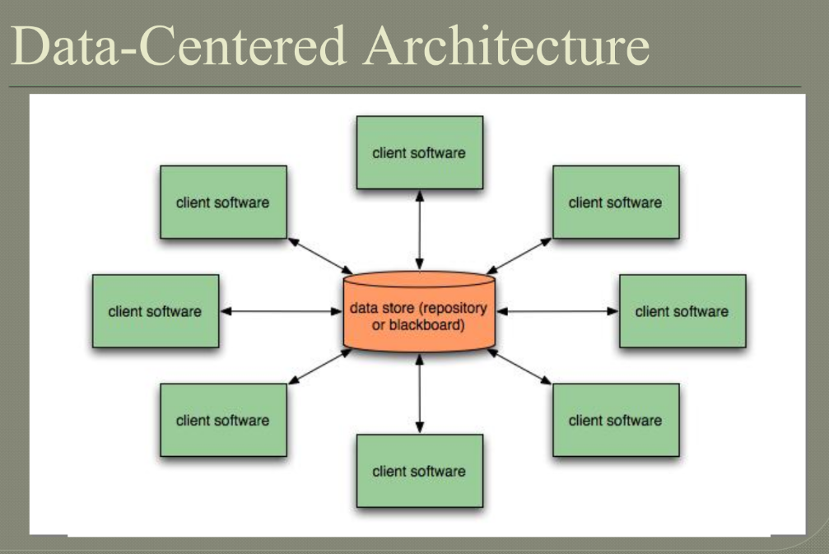

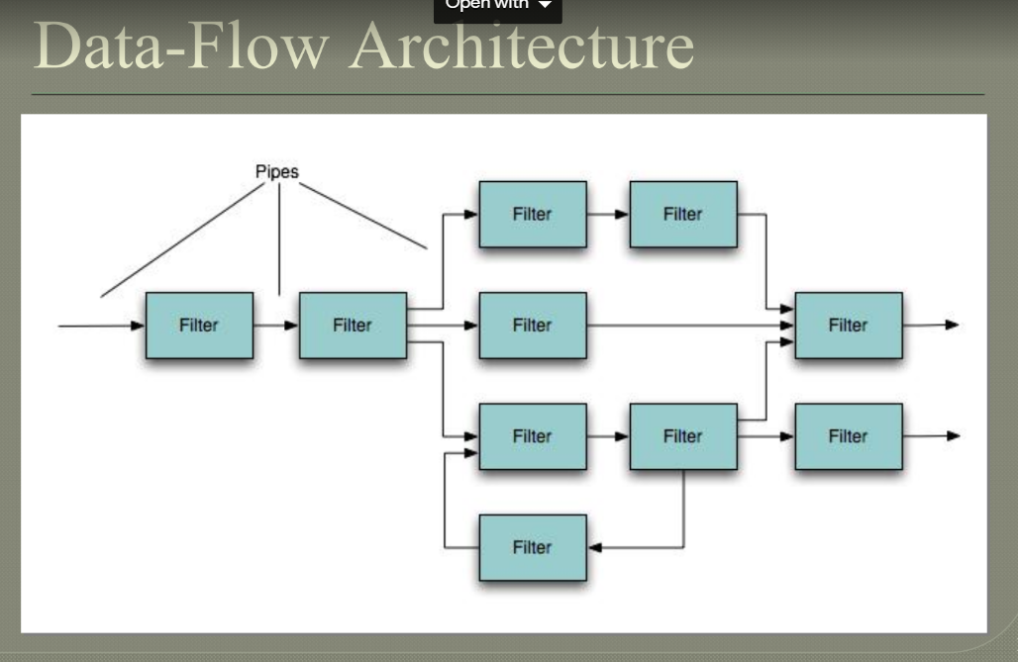

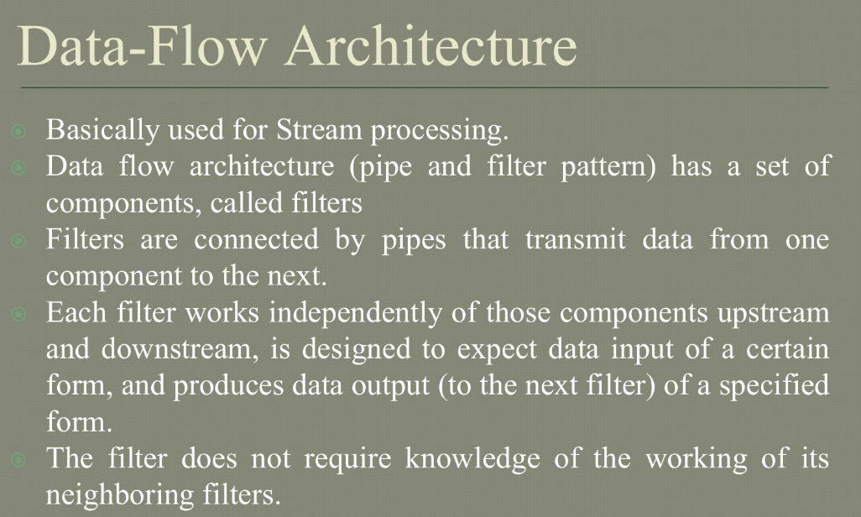

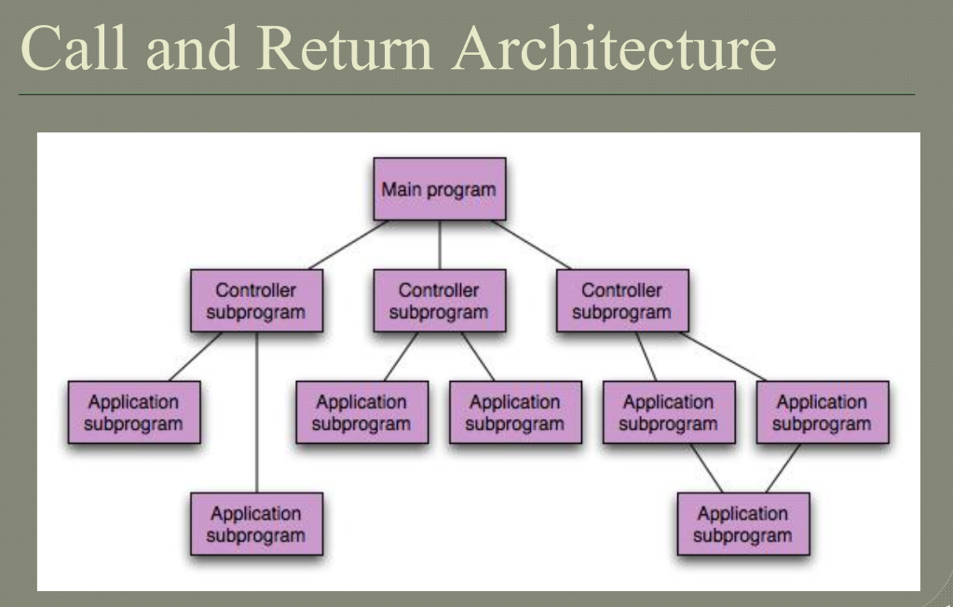

Call and return architecture, also known as subroutine architecture, is a design pattern commonly used in software engineering to structure programs into smaller, reusable components.

In call and return architecture, a program is divided into subroutines or procedures, each of which performs a specific task. When the program needs to perform that task, it "calls" the appropriate subroutine, passing any necessary parameters. The subroutine then executes its instructions and "returns" control back to the calling program.

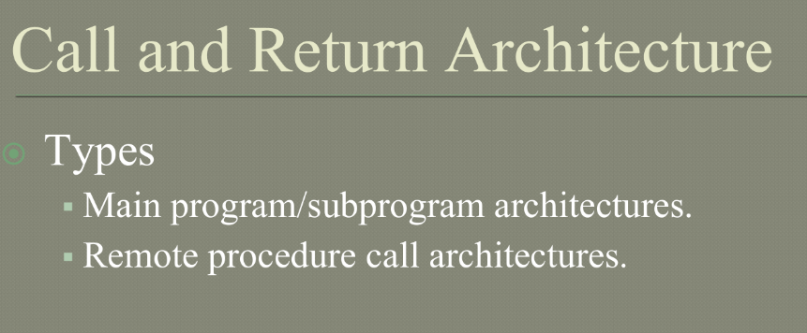

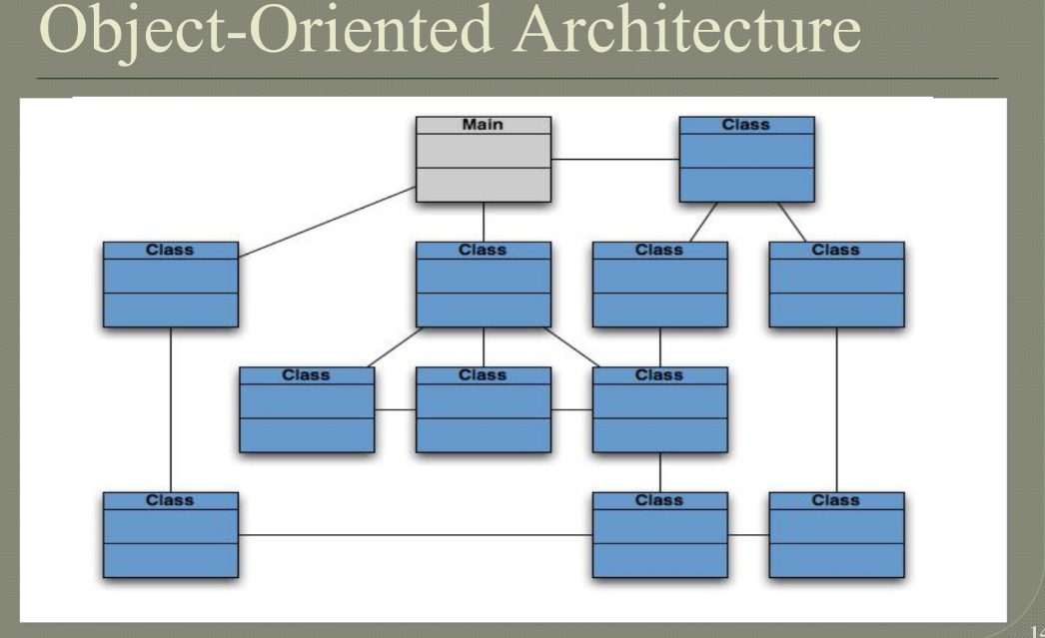

Object-oriented architecture is a design paradigm that is widely used in software engineering. It involves organizing software systems into a collection of objects that communicate with each other through messages.

In an object-oriented architecture, the system is organized into a collection of classes, which define the properties and behavior of objects. Objects are instances of classes, and communicate with each other through messages. The use of object-oriented architecture can promote modularity, flexibility, and code reuse, and is widely used in a variety of software applications.

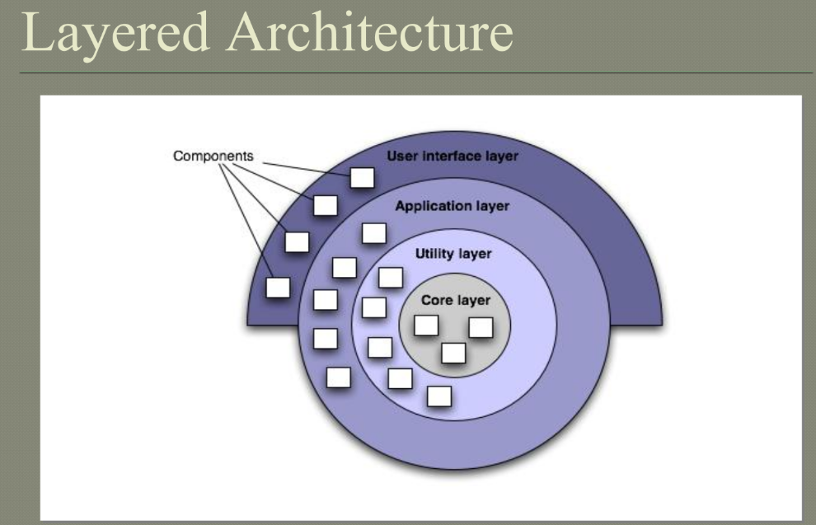

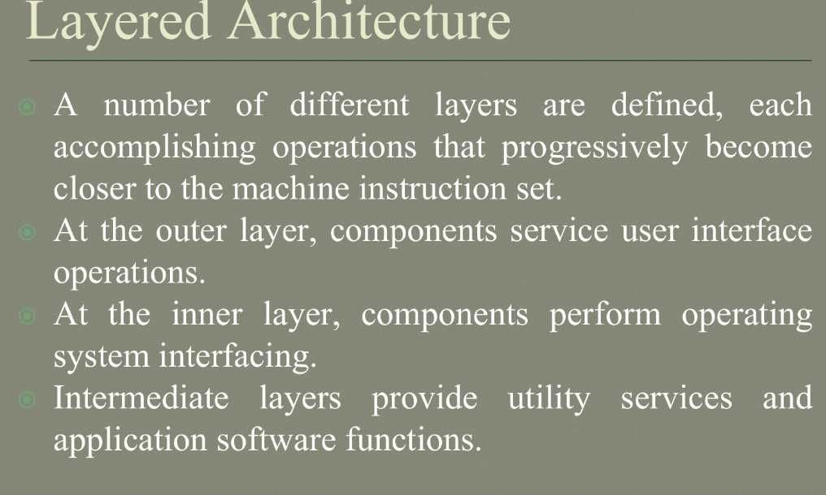

1. **Discuss about the principles of user interface design steps?**
2. **What are the benefits of high cohesion and low coupling?**

High cohesion and low coupling are important design principles in software engineering. The benefits of these principles are as follows:

High cohesion: High cohesion refers to the degree to which elements within a module or component are related to each other. When a module or component has high cohesion, it means that its elements are tightly related and work together to achieve a single, well-defined purpose. Benefits of high cohesion include:

Improved maintainability: Modules or components with high cohesion are easier to maintain because they have clear and well-defined responsibilities.

Increased reusability: High cohesion allows for greater reusability of code, as well-designed modules or components can be easily adapted and reused in other projects or parts of the same project.

Reduced complexity: High cohesion reduces the complexity of the code, as each module or component has a clear and distinct purpose.

Low coupling: Low coupling refers to the degree to which modules or components are dependent on each other. When modules or components have low coupling, it means that they are independent of each other and can be changed or modified without affecting other parts of the system. Benefits of low coupling include:

Improved maintainability: Low coupling makes it easier to maintain code, as changes to one module or component are less likely to have an impact on other modules or components.

Increased flexibility: Low coupling allows for greater flexibility in the design and implementation of a system, as each module or component can be modified or replaced without affecting other parts of the system.

Reduced complexity: Low coupling reduces the complexity of the code, as each module or component has a limited set of dependencies and can be understood and modified more easily

1. **Illustrate Design Principles.**

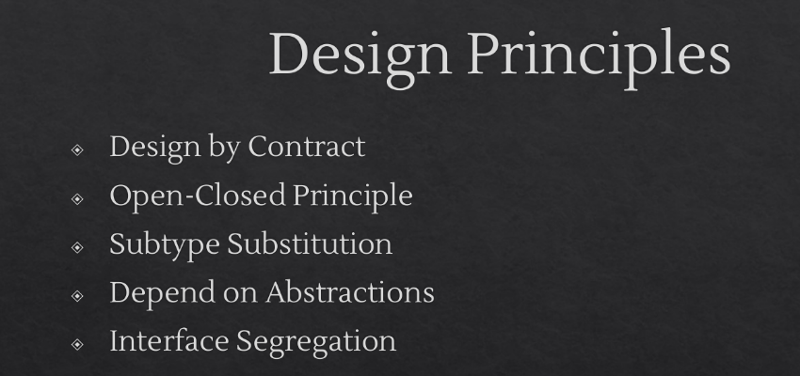

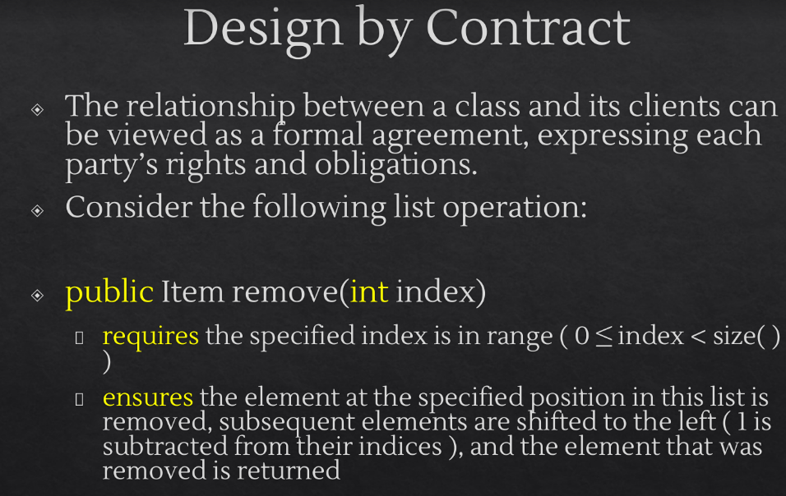

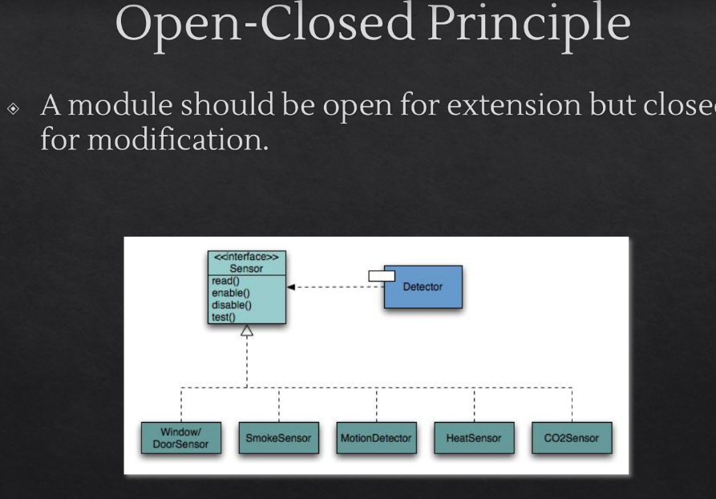

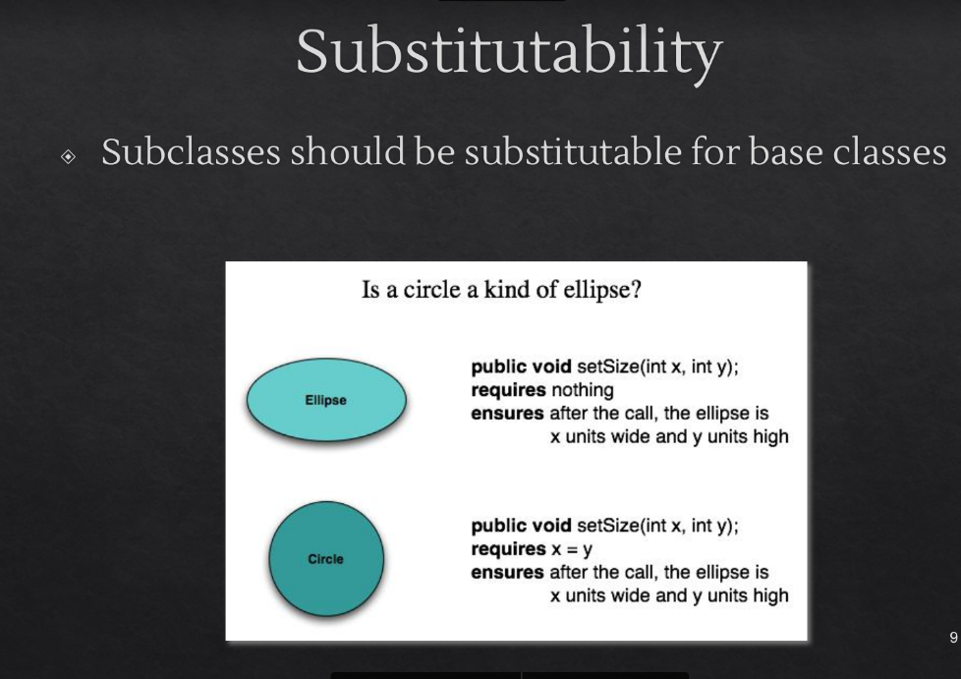

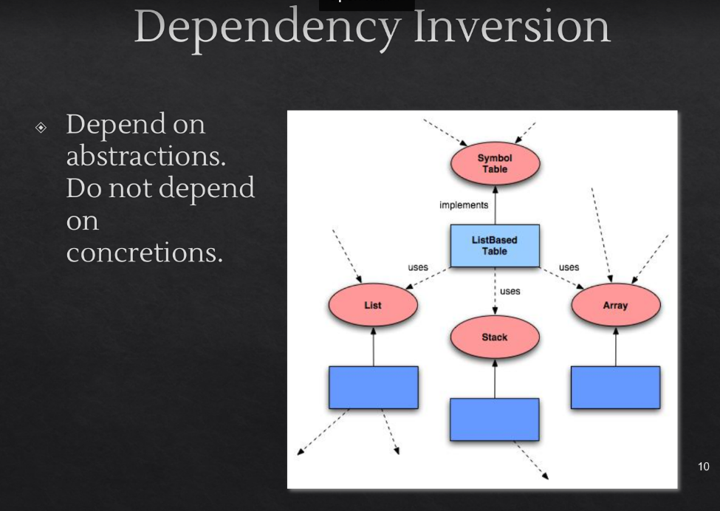

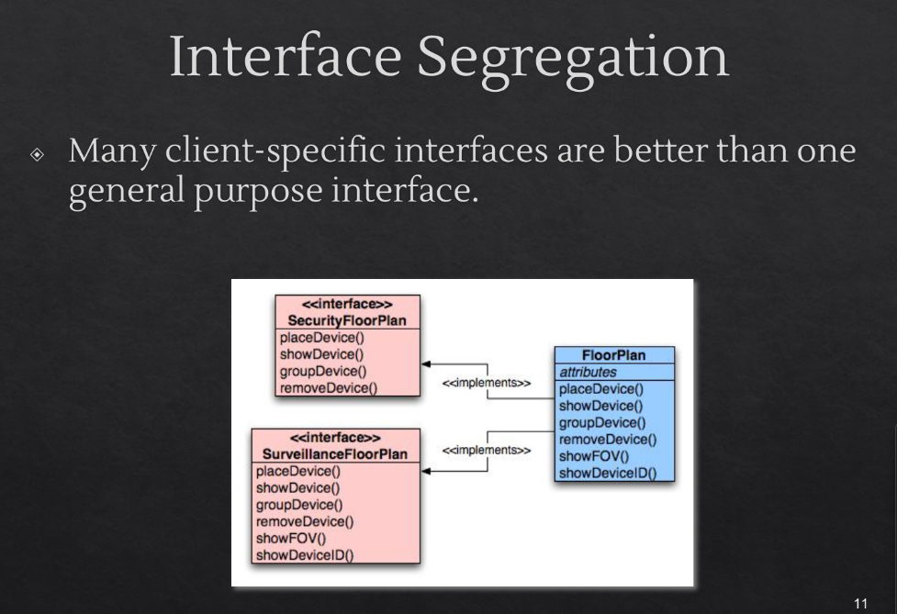

1. **Illustrate design issues.**

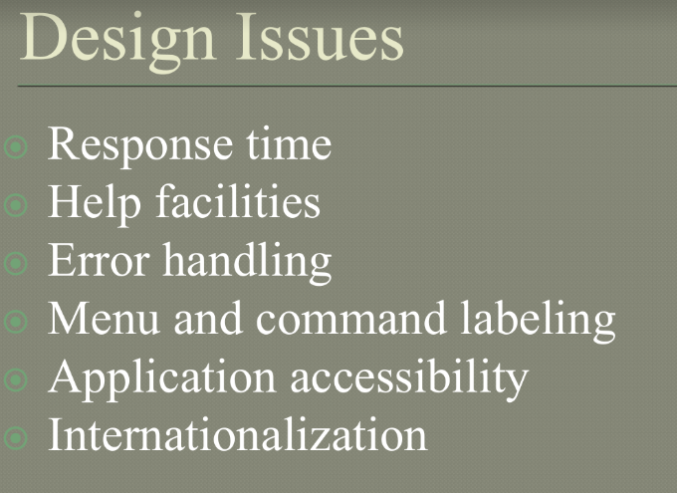

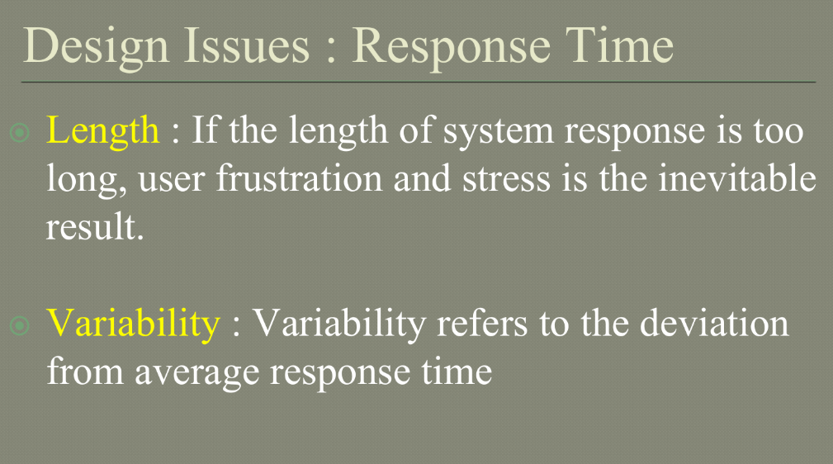

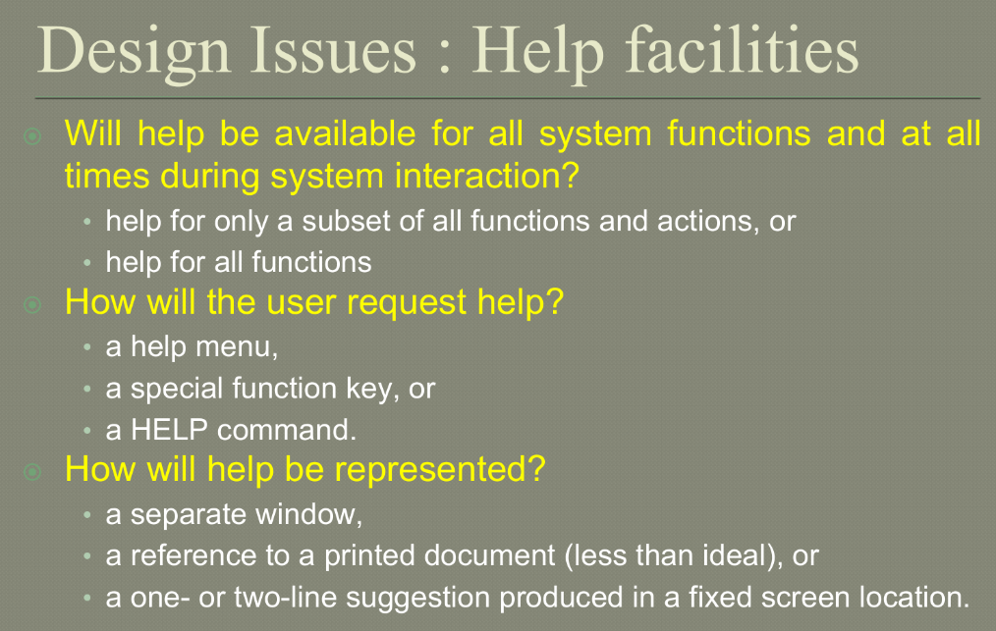

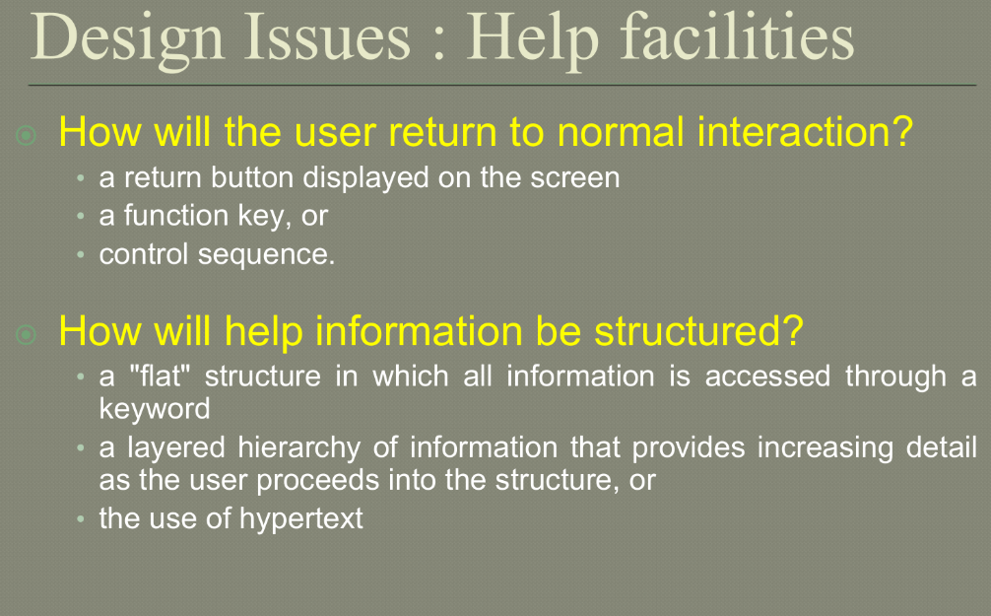

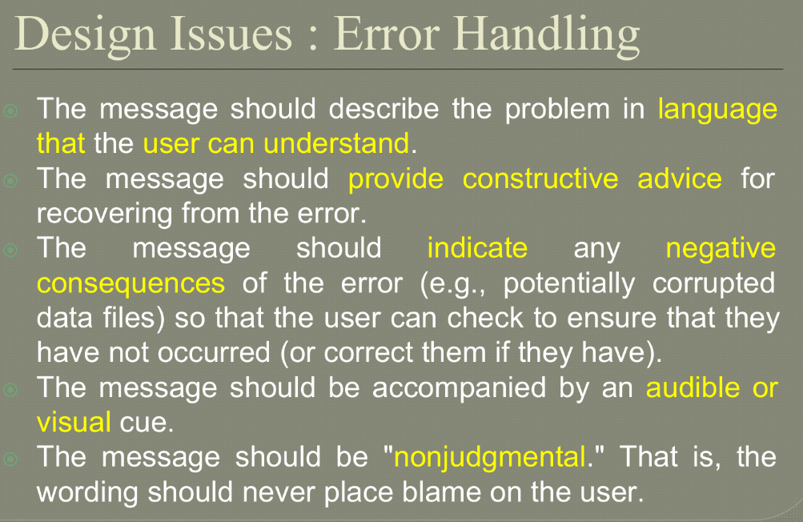

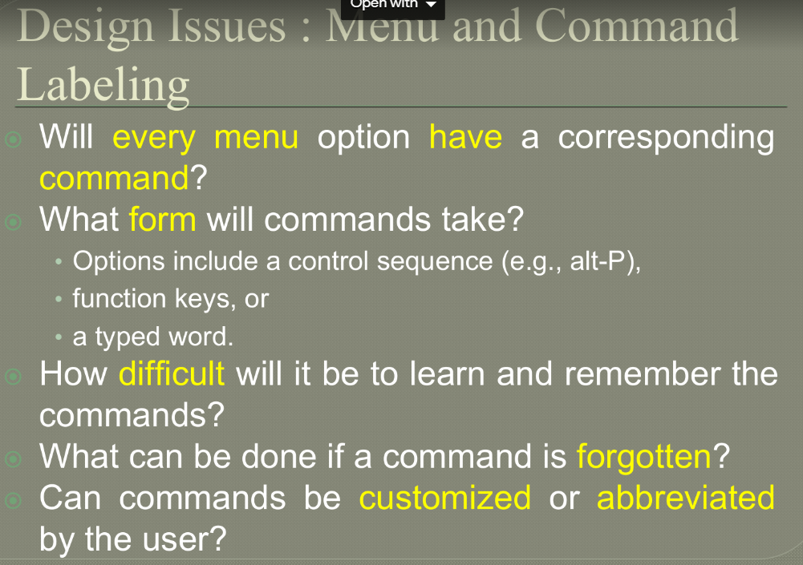

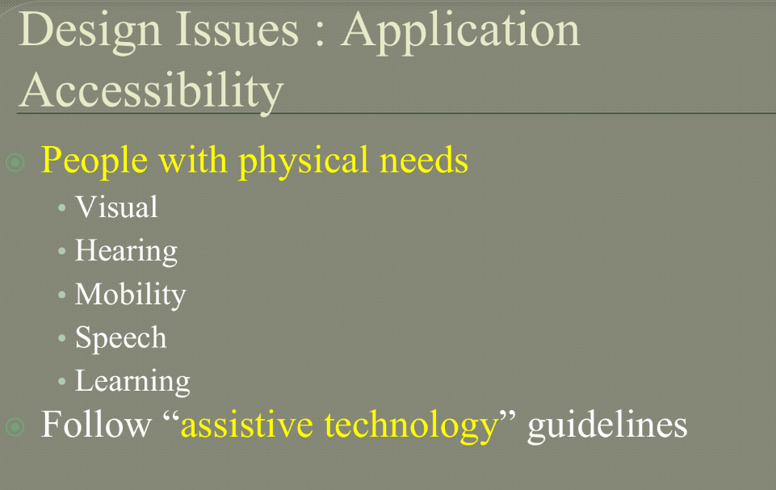

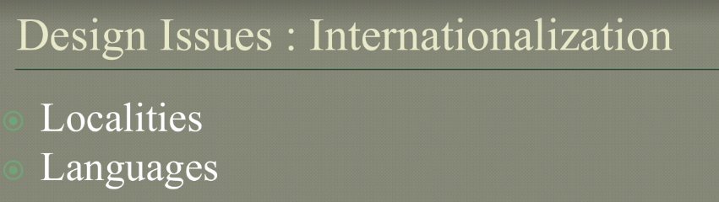

1. **Explain how an analysis model is translated to Design models. Explain in detail the design quality guidelines and attributes.**

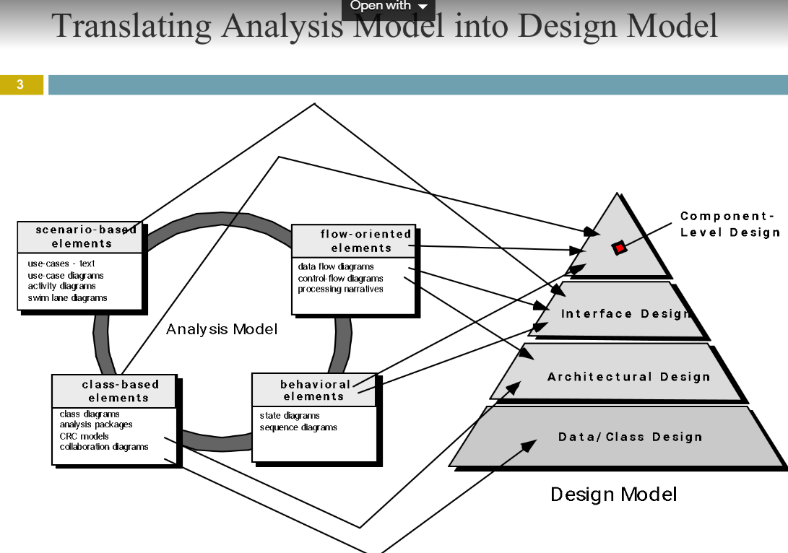

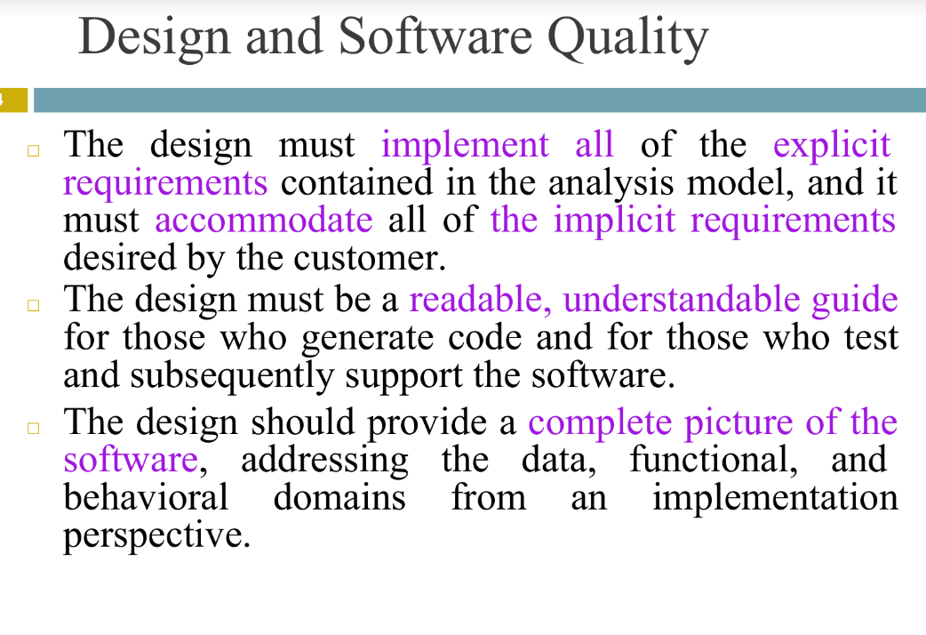

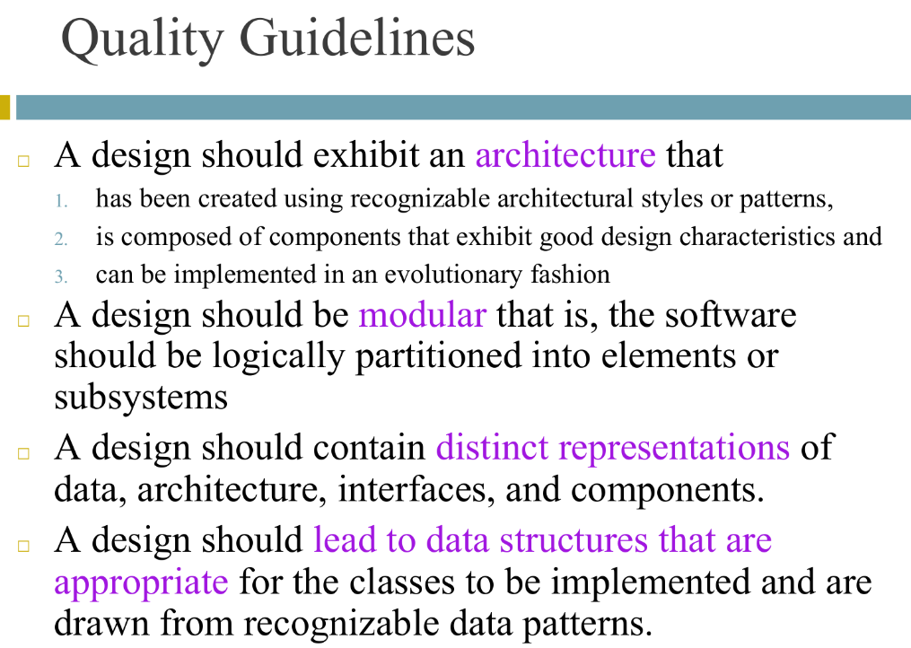

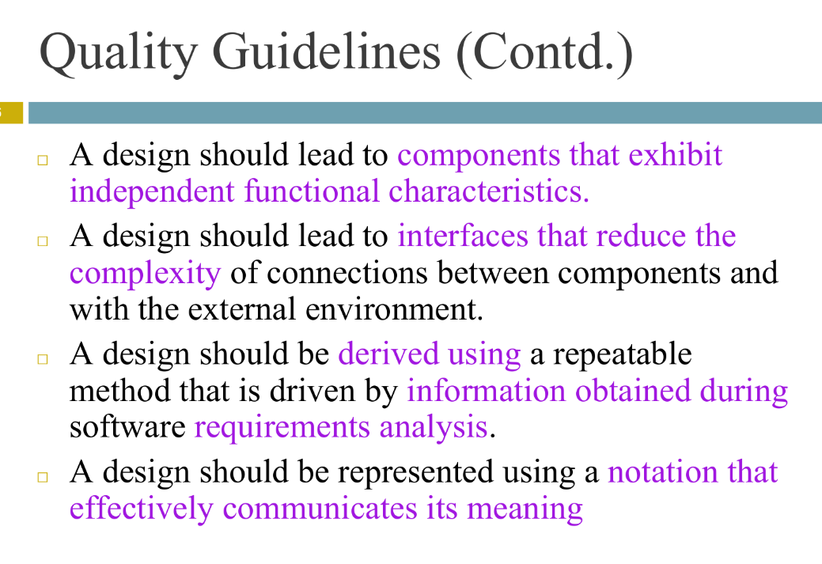

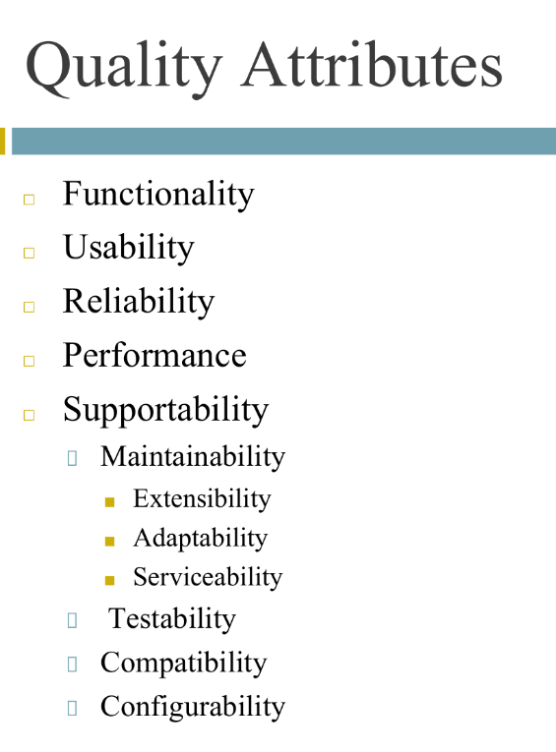

1. **What are the benefits of component based development model? With a neat diagram and explain the different phases of component based development.**
2. **Discuss different categories of risk that help to define impact values in a risk table.**
3. **Illustrate change control and version control.**
4. **What is Change Control? How it is different from version control.**
5. Explain Software configuration process.
6. What are the different types of risk?
7. Explain Software Quality Assurance.
8. Explain Risk Assessment and risk projection.
9. What are the different steps to determine the overall consequences of risks?
10. **Explain the different metrics used for software quality and reliability.**

Quality Metrics

The goal of software engineering is to produce high quality software. To achieve this goal software engineers use effective methods along with modern tools while developing the software. Simply producing the software in this manner is not sufficient, it is necessary to measure the quality of software being software. Basically the quality of software depends upon-

Requirements that describe the problem

The design method used to produce the software

The code that leads to executable program

And the tests that are carried out in order to uncover the errors from the software.

The project manager evaluates the quality of the software project using following factors-

Errors and defects in the software

Quality metrics collected by each software engineer who is involved in the software development process.

Such an evaluation of software quality helps in improving quality assurance and control activities. Typically following metrics are used for software quality-

Work product errors per function

Errors found in the per review hour

Errors found in the testing

This error data is useful in computing the defect removal efficiency. Let us discuss the concept of defect removal efficiency (DRE) and Measuring Quality of software.

1) Measuring Quality

There are many measures of software quality Correctness, Integrity, Usability and Maintainability provide useful indicators to project team

Following are the measure of software quality –

I) Correctness :

Correctness is a degree to which the software produces the desired functionality. The correctness can be measured as

Correctness = Defects per KLOC

Where defects means lack of conformance to requirements. Such defects are generally reported by the user of the program.

II) Integrity:

Integrity is basically an ability of the system to withstand against the attacks. Typically attacks are on programs, data and documents.

There are two attributes that are associated with integrity: threat and security.

Threat is the probability that specific types of attacks may occur.

Security is the probability that the system will repel against the specific attacks.

Integrity can be measure as:

Integrity = ∑ ((1-threat) * (1-security))

III) Usability :

Usability means user friendliness of the system or ability of the system that indicates the usefulness of the system.

Following are the characteristics that are useful for measuring the usability. The user friendliness is measured using following four characteristics –

a) The time required to make the system efficient

b) The skill required to learn the system

c) The net increase in productivity after regular use of the system

d) The user attitude towards the system.

IV) Maintainability :

Maintainability is the ability of the system to accommodate the corrections made after encountering errors, adapting the environment and adapt the changes made in the system in order to satisfy the user.

The metric used for maintainability is MTTC i.e. Mean Time to Change. The MTTC can be defined as the time required to analyse the change request, design an appropriate modification and implementation of those desired changes.

Lower the value of MTTC means the software is more maintainable.

2) Defect Removal Efficiency (DRE)

While developing the software project many work products such as SRS, design document, source code are being created. Along with these work products many errors may get generated. Project manager has to identify all these errors to bring quality software.

Error tracking is a process of assessing the status of the software project.

The software team performs the formal technical reviews to test the software developed. In this review various errors are identified and corrected. Any errors that remain uncovered and are found in later are called defects.

The defects removal efficiency can be defined as:

DRE = E/(E+D)

Where DRE is the defect removal efficiency,

E is the error and

D is defect.

The DRE represents the effectiveness of quality assurance activities. The DRE also helps the project manager to assess the progress of software project as it gets developed through its scheduled work task.

During error tracking activity following metrics are computed

Errors per requirement specification page : denoted by Ereq

Errors per component – design level : denoted by Edesign

Errors per component – code level : denoted by Ecode

DRE – requirement analysis

DRE – architectural design

DRE – component level design

DRE – coding

The project manager calculates current values for Ereq,Edesign,Ecode

. These values are then compared with past projects. If the current differs more than 20 % from the average, then there may be cause for concern and investigation needs to be made in this regard.

These error tracking metrics can also be used for better target review and testing resources.

1. **Explain the various steps involved in change control.**
2. **What is FTR? Explain review guidelines considered during FTR.**

Formal Technical Review:-

• Formal Technical review is a software quality assurance activity performed by software engineer.

Objectives of FTR:-

FTR is useful to uncover error in logic, function and implementation for any representation of the software.

The purpose of FTR is to ensure that software meets specified requirements.

It is also ensure that software is represented according to predefined standards.

It helps to review the uniformity in software development process.

It makes the project more manageable.

• Besides the above mentioned objectives, the purpose of FTR is to enable junior engineer to observer the analysis, design, coding and testing approach more closely.

• Each FTR is conducted as meeting and is considered successfully only if it is properly planned, controlled and attended.

Steps in FTR:-

The review meeting:-

• Every review meeting should be conducted by considering the following constraints-

I) Involvement of people

Between 3 and 5 people should be involve in the review.

II) Advance preparation Advance preparation should occur but it should be very short that is at the most 2 hours of work for each person can be spent in this preparation.

III) Short duration The short duration of the review meeting should be less than two hour.

• Rather than attempting to review the entire design walkthrough are conducted for modules or for small group of modules.

• The focus of the FTR is on work product (a software component to be reviewed). The review meeting is attended by the review leader, all reviewers and the producer.

• The review leader is responsible for evaluating for product for its deadlines. The copies of product material is then distributed to reviewers. -The producer organises “walkthrough” the product, explaining the material, while the reviewers raise the issues based on theirs advance preparation.

• One of the reviewers become recorder who records all the important issues raised during the review. When error are discovered, the recorder notes each.

• At the end of the review, the attendees decide whether to accept the product or not, with or without modification.

Review reporting and record keeping:-

• During the FTR, the reviewer actively record all the issues that have been raised.

• At the end of meeting these all raised issues are consolidated and review issue list is prepared.

• Finally, formal technical review summary report is produced.

Review guidelines:-

• Guidelines for the conducting of formal technical review must be established in advance. These guidelines must be distributed to all reviewers, agreed upon, and then followed.

1. **Explain walkthrough.**

Walkthrough: Method of conducting informal group/individual review is called walkthrough, in which a designer or programmer leads members of the development team and other interested parties through a software product, and the participants ask questions and make comments about possible errors, violation of development standards, and other problems or may suggest improvement on the article, walkthrough can be pre planned or can be conducted at need basis and generally people working on the work product are involved in the walkthrough process.

The Purpose of walkthrough is to:

• Find problems

• Discuss alternative solutions

• Focusing on demonstrating how work product meets all requirements.IEEE 1028 recommends three specialist roles in a walkthrough:

Leader: who conducts the walkthrough, handles administrative tasks, and ensures orderly conduct (and who is often the Author).

Recorder: who notes all anomalies (potential defects), decisions, and action items identified during the walkthrough meeting, normally generate minutes of meeting at the end of walkthrough session.

Author: who presents the software product in step-by-step manner at the walk-through meeting, and is probably responsible for completing most action items.

1. **Differentiate b/w White Box and Black Box Testing**

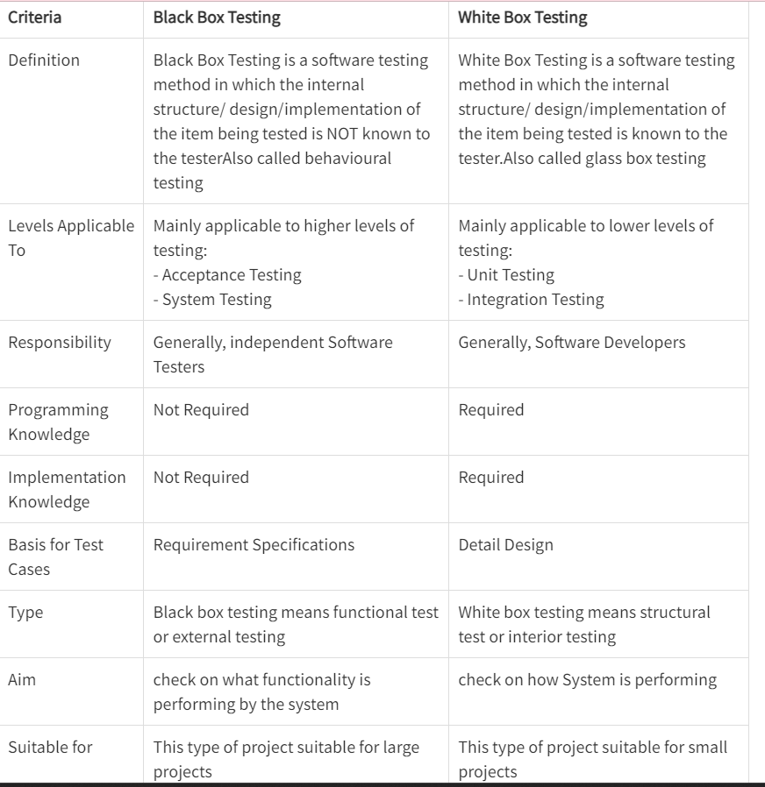

1. **Explain different types of testing.**

Software testing is the process of evaluation a software item to detect differences between given input and expected output. Also to assess the feature of A software item. Testing assesses the quality of the product. Software testing is a process that should be done during the development process. In other words software testing is a verification and validation process. Basics of software testing

There are two basics of software testing: blackbox testing and whitebox testing.

Blackbox Testing Black box testing is a testing technique that ignores the internal mechanism of the system and focuses on the output generated against any input and execution of the system. It is also called functional testing.

Whitebox Testing White box testing is a testing technique that takes into account the internal mechanism of a system. It is also called structural testing and glass box testing. Black box testing is often used for validation and white box testing is often used for verification.

Types of testing

There are many types of testing like

Unit Testing

Integration Testing

Functional Testing

System Testing

Stress Testing

Performance Testing

Usability Testing

Acceptance Testing

Regression Testing

Beta Testing

Unit Testing

Unit testing is the testing of an individual unit or group of related units. It falls under the class of white box testing. It is often done by the programmer to test that the unit he/she has implemented is producing expected output against given input.

Integration Testing

Integration testing is testing in which a group of components are combined to produce output. Also, the interaction between software and hardware is tested in integration testing if software and hardware components have any relation. It may fall under both white box testing and black box testing.

Functional Testing

Functional testing is the testing to ensure that the specified functionality required in the system requirements works. It falls under the class of black box testing.

System Testing

System testing is the testing to ensure that by putting the software in different environments (e.g., Operating Systems) it still works. System testing is done with full system implementation and environment. It falls under the class of black box testing.

Stress Testing

Stress testing is the testing to evaluate how system behaves under unfavorable conditions. Testing is conducted at beyond limits of the specifications. It falls under the class of black box testing.

Performance Testing

Performance testing is the testing to assess the speed and effectiveness of the system and to make sure it is generating results within a specified time as in performance requirements. It falls under the class of black box testing.

Usability Testing

Usability testing is performed to the perspective of the client, to evaluate how the GUI is user-friendly? How easily can the client learn? After learning how to use, how proficiently can the client perform? How pleasing is it to use its design? This falls under the class of black box testing.

Acceptance Testing

Acceptance testing is often done by the customer to ensure that the delivered product meets the requirements and works as the customer expected. It falls under the class of black box testing.

Regression Testing

Regression testing is the testing after modification of a system, component, or a group of related units to ensure that the modification is working correctly and is not damaging or imposing other modules to produce unexpected results. It falls under the class of black box testing.

Beta Testing Beta testing is the testing which is done by end users, a team outside development, or publicly releasing full pre-version of the product which is known as beta version. The aim of beta testing is to cover unexpected errors. It falls under the class of black box testing.

1. **Explain reverse engineering.**

Reverse engineering is taking apart an object to see how it works in order to duplicate or enhance the object. The practice, taken from older industries, is now frequently used on computer hardware and software. Software reverse engineering involves reversing a program's machine code (the string of 0s and 1s that are sent to the logic processor) back into the source code that it was written in, using program language statements.

Reverse-engineering is used for many purposes: as a learning tool; as a way to make new, compatible products that are cheaper than what's currently on the market; for making software interoperate more effectively or to bridge data between different operating systems or databases; and to uncover the undocumented features of commercial products.

Following are reasons for reverse engineering a part or product:

The original manufacturer of a product no longer produces a product

There is inadequate documentation of the original design

The original manufacturer no longer exists, but a customer needs the product

The original design documentation has been lost or never existed

Some bad features of a product need to be designed out. For example, excessive wear might indicate where a product should be improved

To strengthen the good features of a product based on long-term usage of the product

To analyze the good and bad features of competitors' product

To explore new avenues to improve product performance and features

To gain competitive benchmarking methods to understand competitor's products and develop better products

The original CAD model is not sufficient to support modifications or current manufacturing methods

The original supplier is unable or unwilling to provide additional parts

The original equipment manufacturers are either unwilling or unable to supply replacement parts, or demand inflated costs for sole-source parts

To update obsolete materials or antiquated manufacturing processes with more current, less-expensive technologies.

1. **Explain SCM Repositories.**
2. **Explain Reengineering.**

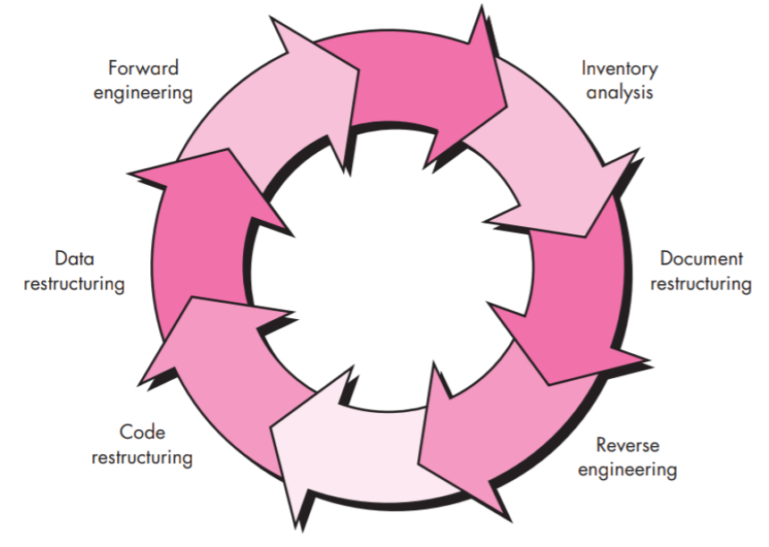

Software engineering covers not only the technical aspects of building software systems, but also management issues, such as directing programming teams, scheduling, and budgeting.

Software engineering is an engineering branch associated with development of software product using well-defined scientific principles, methods and procedures. The outcome of software engineering is an efficient and reliable software product.

Software project management has wider scope than software engineering process as it involves communication, pre and post-delivery support etc.

The need of software engineering arises because of higher rate of change in user requirements and environment on which the software is working.

Large software- It is easier to build a wall than to a house or building, likewise, as the size of software become large engineering has to step to give it a scientific process.

Scalability- If the software process were not based on scientific and engineering concepts, it would be easier to re-create new software than to scale an existing one.

Cost- As hardware industry has shown its skills and huge manufacturing has lower down the price of computer and electronic hardware. But the cost of software remains high if proper process is not adapted.

Dynamic Nature- The always growing and adapting nature of software hugely depends upon the environment in which user works. If the nature of software is always changing, new enhancements need to be done in the existing one. This is where software engineering plays a good role.

Quality Management- Better process of software development provides better and quality software product.

RE Engineering:

• Restructuring or rewriting part or all of a system without changing its functionality

• Applicable when some (but not all) subsystems of a larger system require frequent maintenance

• Reengineering involves putting in the effort to make it easier to maintain

• The reengineered system may also be restructured and should be re-documented

When do you decide to reengineer?

• When system changes are confined to one subsystem, the subsystem needs to be reengineered

• When hardware or software support becomes obsolete

• When tools to support restructuring are readily available

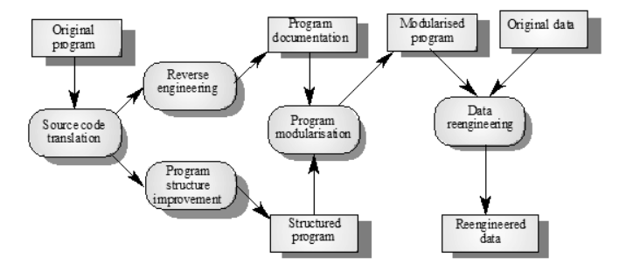

Economics of Reengineering:

• Cost of maintenance: cost annual of operation and maintenance over application lifetime

• Cost of reengineering: predicted return on investment reduced by cost of implementing changes and engineering risk factors

• Cost benefit: Cost of re engineering - Cost of maintenance

Re-engineering advantages:

Reduced risk

There is a high risk in new software development. There may be development problems, staffing problems and specification problems

Reduced cost

The cost of re-engineering is often significantly less than the costs of developing new software

The complete Software Re-Engineering lifecycle includes:

Product Management: Risks analysis, root cause analysis, business analysis, requirements elicitation and management, product planning and scoping, competitive analysis

Research and Innovation: Definition of a problem, data gathering and analysis, identifying a solution and developing best-of-breed or innovative algorithms, verification of quality for data and results, patent preparation

Product Development: Technology analysis and selection, software architecture and design, data architecture, deployment architecture, prototyping and production code development, comprehensive software testing, data quality testing, and product packaging and deployment preparation

Product Delivery and Support: Hardware/Platform analysis and selection, deployment and release procedures definition, installations and upgrades, tracking support issues, organizing maintenance releases.

Project Management: Brings efficiency and productivity to your software re-engineering project by utilizing modern, practical software project management, software quality assurance, data quality assurance, and advanced risk management techniques.

1. **With examples, differentiate between validation and verification.**

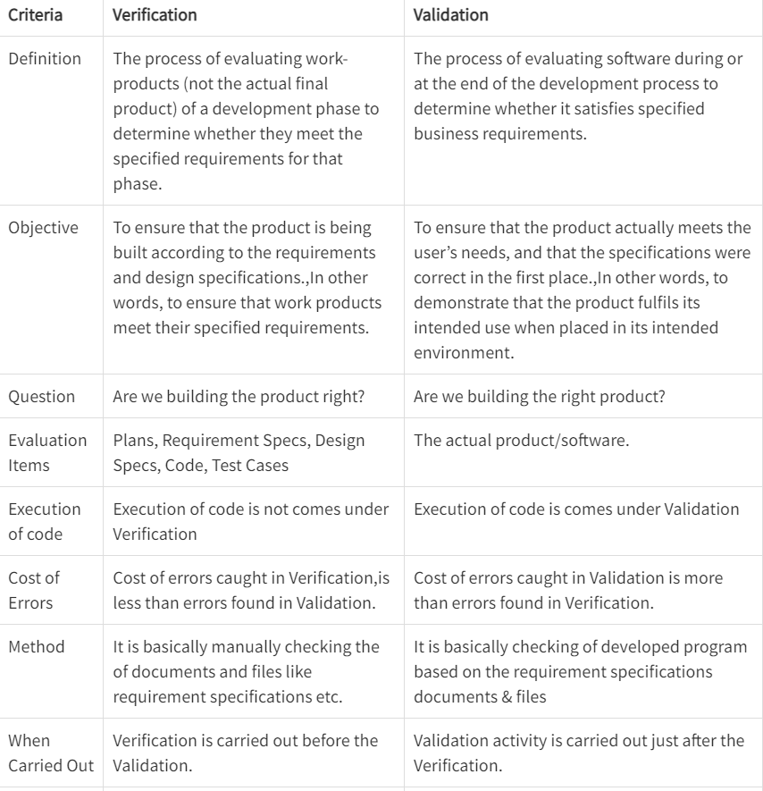

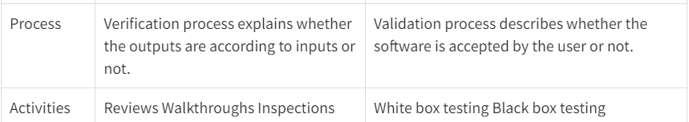

1. **Explain basis path testing and cyclomatic complexity with suitable examples.**

Path Testing:-

Path testing is a structural testing method that involves using the source code of a program in order to find every possible executable path. It helps to determine all faults lying within a piece of code. This method is designed to execute all or selected path through a computer program.

Basis Path Testing:-

The basis path testing is same, but it is based on a White Box Testing method, that defines test cases based on the flows or logical path that can be taken through the program. Basis path testing involves execution of all possible blocks in a program and achieves maximum path coverage with least number of test cases. It is a hybrid of branch testing and path testing methods.

The objective behind basis path testing is that it defines the number of independent paths, thus the number of test cases needed can be defined explicitly (maximizes the coverage of each test case).

Here we will take a simple example, to get better idea what is basis path testing include.

In the above example, we can see there are few conditional statements that is executed depending on what condition it suffice.

Here there are 3 path or condition that need to be tested to get the output,

• Path 1: 1,2,3,5,6, 7

• Path 2: 1,2,4,5,6, 7

• Path 3: 1, 6, 7

Basis Path Testing

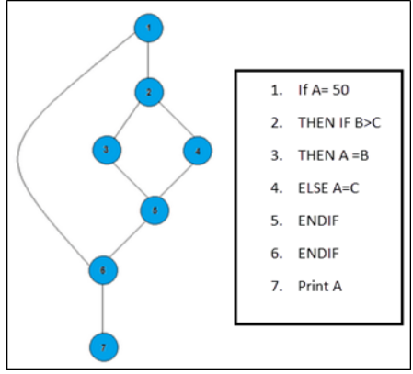

Steps for Basis Path testing

The basic steps involved in basis path testing include

• Draw a control graph (to determine different program paths)

• Calculate Cyclomatic complexity (metrics to determine the number of independent paths)

• Find a basis set of paths

• Generate test cases to exercise each path

Benefits of basis path testing

• It helps to reduce the redundant tests

• It focuses attention on program logic

• It helps facilitates analytical versus arbitrary case design

• Test cases which exercise basis set will execute every statement in program at least once.

Independent paths:

An independent path is any path through the graph that introduces at least one new set of processing statement or new condition. An independent path must move along at least one edge that has not been traversed before the path is defined.

cyclomatic complexity:

cyclomatic complexity can be designed through the given formula

v(6) = e - n + 2p

where

e is the no. of edges

n is the no. of nodes in the graph

p is the no. of components in the whole graph.

void main c { int a, b, c, max,

1. print f ('enter 3 integers"),
2. scan f (" %d %d %d", & a, & , & c),b
3. if (a >) b
4. if ( a > c)
5. Max = a
6. else max = c,
7. else if (b > c)
8. Max = b
9. else max = c

10.print and ( "a max = % d", max), 3

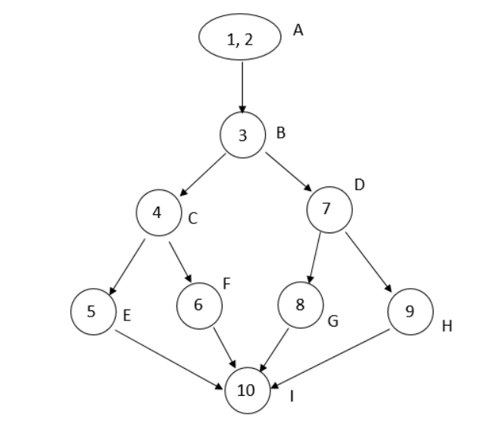

No. of independent paths

v (a) = e - n + 2

= 11 - 9 + 2

= 4

No. of procedures = 1

∴

cyclomatic complexity

= e - n + 2 P

= 11 - 9 + 2

= 4

1. **Explain the different OO testing methods.**

Object Oriented Testing methods:

Testing is a continuous activity during software development. In object-oriented systems, testing encompasses three levels, namely, unit testing, subsystem testing, and system testing.

Unit Testing:

In unit testing, the individual classes are tested. It is seen whether the class attributes are implemented as per design and whether the methods and the interfaces are error-free.

Unit testing is the responsibility of the application engineer who implements the structure.

Subsystem Testing:

This involves testing a particular module or a subsystem and is the responsibility of the subsystem lead. It involves testing the associations within the subsystem as well as the interaction of the subsystem with the outside.

Subsystem tests can be used as regression tests for each newly released version of the subsystem.

System Testing:

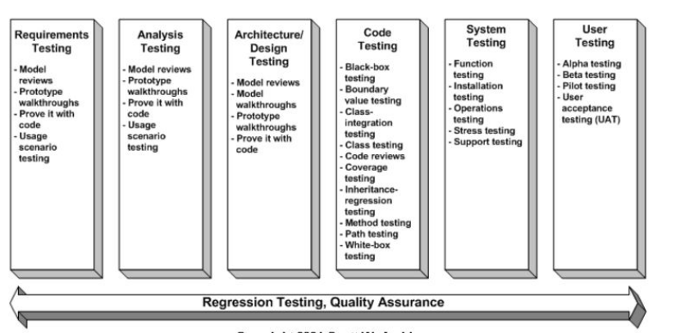

System testing involves testing the system as a whole and is the responsibility of the quality-assurance team. The team often uses system tests as regression tests when assembling new releases. enter image description here

Object-Oriented Testing Techniques:

Grey Box Testing:

The different types of test cases that can be designed for testing object-oriented programs are called grey box test cases. Some of the important types of grey box testing are:

State model based testing: This encompasses state coverage, state transition coverage, and state transition path coverage.

Use case based testing: Each scenario in each use case is tested.

Class diagram based testing: Each class, derived class, associations, and aggregations are tested.

Sequence diagram based testing: The methods in the messages in the sequence diagrams are tested.

Techniques for Subsystem Testing:

The two main approaches of subsystem testing are:

Thread based testing: All classes that are needed to realize a single use case in a subsystem are integrated and tested.

Use based testing: The interfaces and services of the modules at each level of hierarchy are tested. Testing starts from the individual classes to the small modules comprising of classes, gradually to larger modules, and finally all the major subsystems.

Categories of System Testing:

Alpha testing: This is carried out by the testing team within the organization that develops software.

Beta testing: This is carried out by select group of co-operating customers.

Acceptance testing: This is carried out by the customer before accepting the deliverables.

Black-box testing:

Testing that verifies the item being tested when given the appropriate input provides the expected results.

Boundary-value testing:

Testing of unusual or extreme situations that an item should be able to handle.

Class testing:

The act of ensuring that a class and its instances (objects) perform as defined.

Component testing:

The act of validating that a component works as defined.

Inheritance-regression testing:

The act of running the test cases of the super classes, both direct and indirect, on a given subclass.

Integration testing:

Testing to verify several portions of software work together.

Model review:

An inspection, ranging anywhere from a formal technical review to an informal walkthrough, by others who were not directly involved with the development of the model.

Path testing:

The act of ensuring that all logic paths within your code are exercised at least once.

Regression testing:

The acts of ensuring that previously tested behaviors still work as expected after changes have been made to an application.

Stress testing:

The act of ensuring that the system performs as expected under high volumes of transactions, users, load, and so on.

Technical review:

A quality assurance technique in which the design of your application is examined critically by a group of your peers. A review typically focuses on accuracy, quality, usability, and completeness. This process is often referred to as a walkthrough, an inspection, or a peer review.

User interface testing:

The testing of the user interface (UI) to ensure that it follows accepted UI standards and meets the requirements defined for it. Often referred to as graphical user interface (GUI) testing.

White-box testing:

Testing to verify that specific lines of code work as defined. Also referred to as clear-box testing.

1. **What is maintenance and different types? Explain the steps for creating the maintenance log.**
2. Explain glass path testing gin detail.
3. **What are the PMBOK areas?**
4. **Differentiate between alpha and beta testing.**

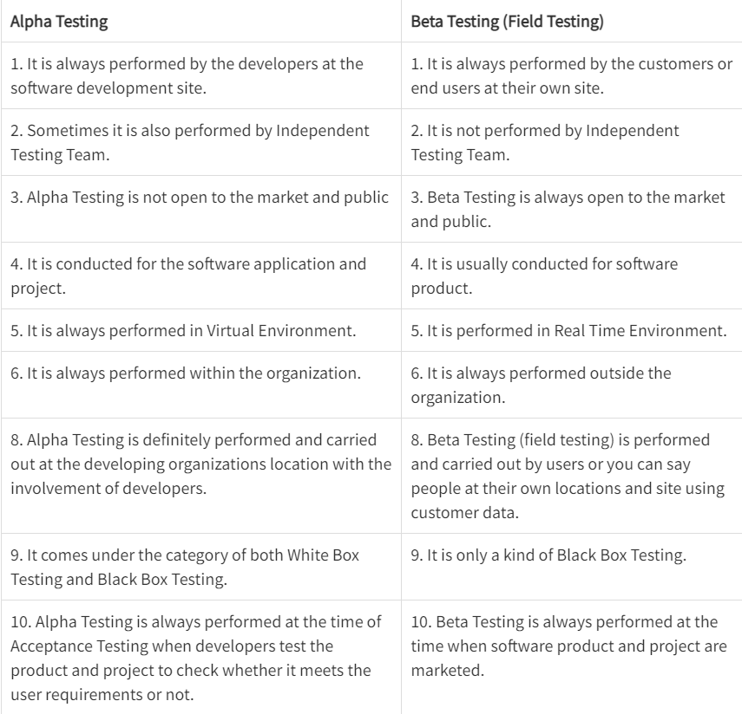

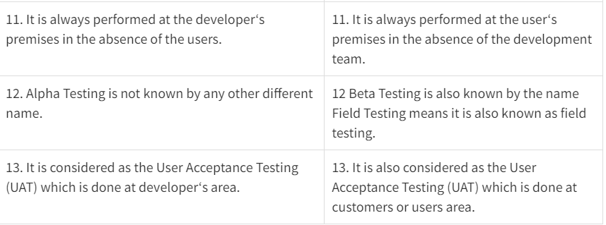

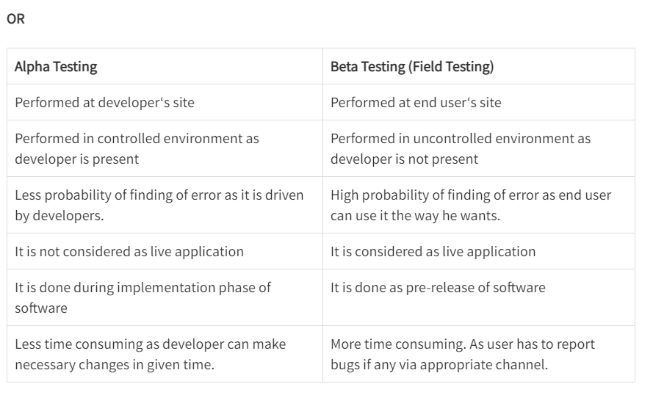

1. **Short note on test driven development.**
2. **Describe boundary value analysis with suitable examples.**
3. **Write a note on: Schedule and Cost slippage.**
4. **Explain the relationship among scope, schedule, and budget?**
5. **What is a Project? What are the attributes of a project?**

A project can be defined as a temporary endeavour undertaken to accomplish a unique product, services or results.

Project can be sequences of task which is planned from beginning to end bounded by time, resources, and required result.

The Following are the attributes of Project:

a. Time frame: Because a project is a temporary endeavour, it must have a definite beginning and end. Many projects begin on a specific date and the date of completion is estimated. Some project has an immovable date when the project must be completed.

b. Purpose: An IT Project can produce any number of results such as a system, a software package, or a recommendation based on a study. Therefore a project’s goal must be to produce something tangible and of value to the organization. A Project must have a goal to drive the project in terms of defining the work to be done.

c. Ownership: The project must provide something of value to an individual or group who will own the project product after it is completed. Determining who owns this project is not always easy. For example, different groups may fight over the does and does not own the system, the data, the support, and the final cost of implementing and maintaining the system.

d. Resources: IT project require time, money, people, and technology. Resources provide the means for achieving a project’s goal and also act as a constraint. For example, the project’s scope, or work to be accomplished is determined directly by the project’s goal. If project sponsor asks that an additional feature to be added to the system, however, this will required additional resources in terms of more work on the part of project team.

e. Roles: IT Projects require different individuals with different skills set, they are listed below.

1. Project Manager: She/he is responsible for ensuring that all of the project management and technical development processes are in place and being carried out properly.

2. Project sponsor: The project sponsor may be the client, customer, or organizational resources manager who will act as champion for the project.

3. Subject matter experts: The subject matter expert may be user or client who has specific knowledge, expertise, or insight in a specific functional area.

4. Technical Expert: Technical expert is needed to provide a technical solution to organization problems.

Risks and Assumptions: All projects have an element risk. Risk can arise from many sources, both and external and internal to the project team. For example, internal risk may arise from estimation process. On other hand, external risk may arise due to dependencies on other contractors or vendors.

Interdependent Tasks: Project work requires many interdependent tasks. For example, a network cannot an installed until the hardware is delivered. Or certain requirements cannot be incorporated into design until key user is interviewed.

Organizational Change: Project is planned organizational change. Change must be understood and managed because implementation of the IT project will change the ways people work.

Operating in an Environment Larger than the project itself: Organization chooses projects for a number of reasons, and the projects chosen can impact the organization.

Project Management: Project management is the applications of knowledge, skills, tools and techniques to project activities to meet project requirements. The planning and organization of an organization's resources in order to move a specific task, event or duty toward completion. Project management typically involves a one-time project rather than an ongoing activity, and resources managed include both human and financial capital.

1. **Explain how Gantt Chart can be used for planning and controlling small projects with suitable examples? What are the limitations of the Gantt chart?**

Gantt Chart:

The Gantt chart is actually modified bar chart in which horizontal bars are drawn for each activity in proportion to the time required for completing it.

It is frequently used to keep track of multiple machine schedules.

This chart provides an immediate comparison between schedule and reality (i.e. planned work and actual progress of work.)

This is achieved simply by marking the planned work and the actual progress of work on the chart.

A cursor attached to Gantt chart can be moved across the chart to compare between the actual progress and planned work till any particular date.

Advantages of Gantt chart :

It is simple graphical display techniques , suitable for less complex situations.

It is extremely easy to understand.

There is clarity in communicating important shop information by using Gantt chart

It can quickly reveal the current or plan situation to all concerned.

Disadvantages of Gantt chart :

The Gantt chart must be updated periodically to account for new jobs.

It is used for communicate relatively less information.

Required greater time to maintain.

Lack of adequate depiction interrelationship between the separate tasks.

1. **What are the advantages of including milestones in the WBS? Why should the WBS be deliverable oriented?**
2. **What do you mean by Project Charter and Plan? Are they different?**
3. **Explain in detail 4 P's of project management.**

The people:

People of a project includes from manager to developer, from client to finish user. however principally people of a project highlight the developers. it's thus vital to own extremely skillful and intended developers that the software package Engineering Institute has developed land Management Capability Maturity Model (PM-CMM), “to enhance the readiness of software package organizations to undertake progressively advanced applications by serving to to draw in, grow, motivate, deploy, and retain the talent required to boost their software package development power”. Organizations that brought home the bacon high levels of maturity within the people management space have a better chance of implementing effective software package engineering practices.

The following categories of people are involved in the software process.

Senior Managers

Project Managers

Practitioners

Customers

End Users

Senior Managers define the business issue. Project Managers plan,motivate, Organize and control the practitioners who do the Software work.Practitioners deliver the technical skills that are necessary to engineer a product or application.Customer specifies the requirements for the software to be developed.End Users interact with the software once it is released.

The Product:

Product is any package that needs to be developed. To develop with success, product objectives and scope ought to be established, various solutions ought to be thought of, and technical and management constraints ought to be known. while not this data, it's not possible to outline cheap and correct estimates of the price, a good assessment of risk, a sensible breakdown of project tasks or a manageable project schedule that gives a meaning indication of progress. Before a software project is planned, the product objectives and scope should be established, technical and management constraints should be identified. Without this information it is impossible to define a reasonable cost,amount of risk involved,the project schedule etc. A software project scope must be unambiguous and understandable at the management and technical levels. To develop a reasonable project plan we have to functionally decompose the problem to be solved.

The Process:

A package method provides the framework from that a comprehensive arrange for package development is established. variety of various tasks sets— tasks, milestones, work merchandise, and quality assurance points—enable the framework activities to be custom-made to the characteristics of the package project and therefore the necessities of the project group. Finally, umbrella activities becomes more prominent method model. Umbrella activities ar freelance of anybody framework activity and occur throughout the method. Here the important thing is to select an appropriate process model to develop the software.There are different process models available.They are Water fall model,Iterative water fall model,Prototyping model,Evolutionary model,RAD(Rapid Application Development) model, Spiral model.In practice we may use any one of the above models or a combination of the above models.

The Project:

Here, the manager needs to perform some job. The project contains all and everything of the entire development method and to avoid project failure the manager needs to take some steps, needs to fret concerning some common warnings etc. In order to manage a successful software project,we must understand what can go wrong (so that problems can be Avoided)and how to do it right. A project is a series of steps where we need to make accurate decision so as to make a successful project.

1. 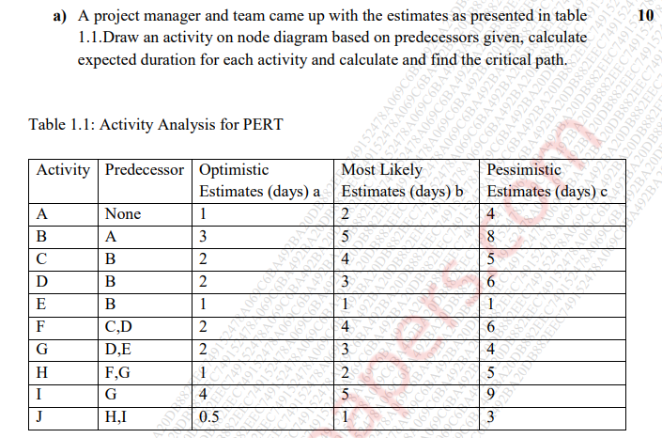

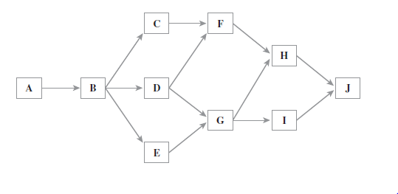

Expected Duration Calculation

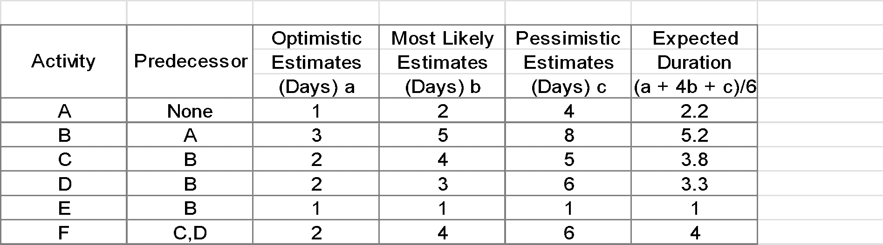

**Critical Path Calculation**

Possible PERT Activity Paths

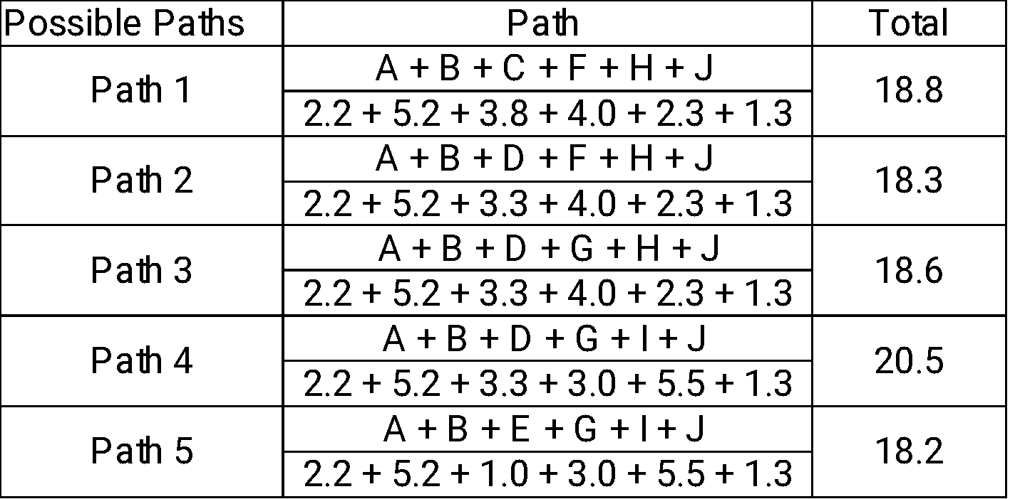

Path 4 is critical path with 21 days duration.

**75**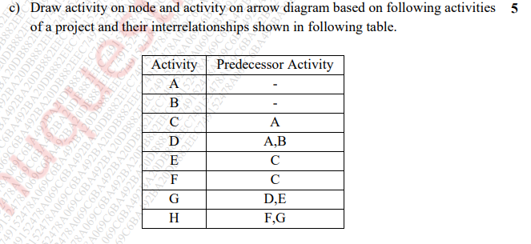

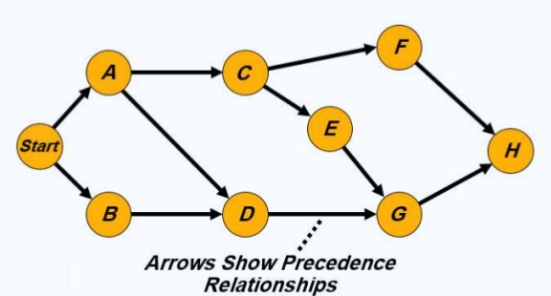

**Activity on Arrow**

